A

PROJECT REPORT

ON

**LAPTOP AND DESKTOP RENTAL MANAGEMENT SYSTEM**

BY

**PRANALI PANDURANG ROKADE**

**ROLL NO. 23504**

SUBMITTED TO

**SAVITRIBAI PHULE PUNE UNIVERSITY**

IN PARTIAL FULFILLMENT OF THE REQUIREMENT

FOR THE AWARD OF THE DEGREE OF

**MASTER OF COMPUTER APPLICATION**

UNDER THE GUIDANCE OF

MS. NEETA RASKAR

THROUGH

**SADHU VASWANI INSTITUTE OF MANAGEMENT STUDIES FOR GIRLS**

6, KOREGAON ROAD, PUNE 411001

2024-25



**CERTIFICATE**

This is to certify that “**PRANALI PANDURANG ROKADE”, Seat No. 23504** of **MCA II SEM – III** has been completed the Mini Project entitled **“LAPTOP AND DESKTOP RENTAL MANAGEMENT SYSTEM”** for the fulfilment of **MASTER OF COMPUTER APPLICATION** under **Savitribai Phule Pune University, Pune.** This is the result of the original project work under the supervision and guidance of **“Ms. Neeta Raskar”** to the best of my knowledge and belief.

The project is completed to our satisfaction and is submitted in partial fulfillment of requirement for Master of Business Administration Program as per the rules of the Savitribai Phule Pune University.

Ms. Neeta Raskar Ms. Neeta Raskar Dr. B H Nanwani

Project Guide HOD Director

Date:

Place: Pune

____________________ ____________________

Sign of External Examiner Sign of Internal Examiner

**DECLARATIOBY STUDENT**

To,

The Director,

SVIMS, Koregaon Park, Pune

I, undersigned hereby declare that this project titled, “**LAPTOP AND DESKTOP RENTAL MANAGEMENT SYSTEM”** written and submitted by me to SPPU, Pune, in partial fulfilment of the requirement of the award of the degree of **MASTER OF COMPUTER APPLICATION (MCA-II)** under the guidance of **Ms** **Neeta Raskar,** is my original work.

I further declare that to the best of my knowledge and belief, this project has not been submitted to this or any other University or Institution for the award of any

Degree.

|  |  |
| --- | --- |
| **Place: Pune** |  |
| **Date:** | **(PRANALI PANDURANG ROKADE)** |

**ACKNOWLEDGEMENT**

I am overwhelmed in all humbleness and gratefulness to acknowledge all those who have helped me to put the ideas, well above the level of simplicity and into something concrete.

I owe a great debt to my guide **Ms. Neeta Raskar** who provided wholesome direction and support to me at every stage of this work. Her wisdom, knowledge and commitment to the highest standards inspired and motivated me. My gratitude is also due to our Director **Dr. B H Nanwani**, for her unconditional support and guidance.

**Place: Pune**

**Date:**

**PRANALI PANDURANG ROKADE**

INDEX

|  |  |  |
| --- | --- | --- |
| **CHAPTER** | **DETAILS** | **PAGE NO** |
| 1 | CHAPTER 1: INTRODUCTION   * 1. Client/Organization Profile   2. Need for System   3. Scope& Feasibility of Work   4. Operating Environment – H/w & S/w   5. Architecture of system   6. Detail Description of Technology Used |  |
|  |
|  |
|  |
|  |
|  |
| 2 | PROPOSEDSYSTEM   * 1. Proposed System   2. Objectives of System   3. User Requirements |  |
|  |
|  |
|  |
| 3 | ANALYSIS & DESIGN   * 1. DFD   2. Table specifications (Database)   3. ERD   4. Object Diagram   5. Class Diagram   6. Use Case Diagrams   7. Web Site Map Diagram (if Website) |  |
|  |
|  |
|  |
|  |
|  |
|  |
|  |
| 4 | USER MANUAL   * 1. User Interface Design (Screens etc.)   2. Limitations   3. Future enhancement |  |
| **5** | BIBLIOGRAPHY  ANNEXURE: SAMPLEPROGRAMCODE  Synopsis |  |
|  | Progress Report |  |

1. **INTRODUCTION**

“Laptop and Desktop Management System” is a web based application which is developed in PHP and MySQL server. It helps customer to book laptop or desktop online. “Laptop and Desktop Management System” contain data of products related to laptop and desktop. The main purpose of “Laptop and Desktop Management System” is to systematically record, store and update recorded data.

The proposed system is completely integrated online system. It automates manual procedure in an effective and efficient way. This automated system facilitates customers and provides to fill up the details according to their requirements. The purpose of this system is to develop a website for the people who can book their laptop or desktop along with requirements from any part of the world.

**Project Overview**

We aim to become a pioneer in the laptop and desktop rental industry by completely focusing on customers, our employees, growth, innovation and efficiency. All of these elements will drive us towards success and show us as one company that can perform and give value for money.

When it comes to laptop and desktop rental services, Cool Service is the most trusted and reliable name in the laptop and desktop business. The most advanced offering laptop and desktop rental services making full use of information technology to improve the level of our efficiency. However, this is only one aspect of services. And this project continually strive to offer the best of services - both in terms of man and machine, to our clients  
Moreover, this project has a fleet of laptop and desktop ranging from luxury to laptop and desktop. While, it offers online laptop and desktop for corporate houses and induvial. And this project claim to offer the best of rates, which are tailor-made depending upon the facilities, availed and offer both intercity and intra-city laptop and desktop facilities. However, this project has strategic backup system for any eventuality.   
Further, this project’s utmost priority is quality. To achieve this, laptop and desktops are well maintained and tested for delivering optimum and uninterrupted performance.

Laptop and desktop Rental Management System is an innovative thought to simplify the rental problems of laptop and desktop of an organization. In the present System, Organization do maintain a person for the allocating and proper functioning of laptop and desktop.

* To produce a web based application that allow customers to register and reserve laptop and desktop online and for the corporate and individual to manage their rental services.
* Maintenance is a huge problem.
* Updating, changes in details is a tedious task.
* Performance is not achieved up to the requirements.
* To ease customer’s task whenever they need to rent laptop and desktop.

**1.2) Need of System:**

A laptop and desktop rental management system is essential for several reasons:

### 1. **Efficiency in Operations**

* **Streamlined Processes**: Automates rental procedures, reducing manual errors and saving time.
* **Inventory Control**: Keeps track of available devices, preventing overbooking.

### 2. **Improved Customer Experience**

* **User-Friendly Interface**: Customers can easily browse available devices, make bookings, and manage rentals online.
* **Real-Time Availability**: Immediate access to device availability enhances customer satisfaction.

### 3. **Effective Tracking and Reporting**

* **Rental History**: Maintains records of past rentals, helping with customer service and inventory management.
* **Financial Insights**: Generates reports on revenue, rental trends, and device utilization.

### 4. **Risk Management**

* **Condition Monitoring**: Tracks the condition of devices, prompting maintenance as needed to reduce wear and tear.
* **Security Features**: Safeguards sensitive customer data and rental agreements.

### 5. **Flexible Pricing and Promotions**

* **Dynamic Pricing**: Adjust rental rates based on demand or duration, maximizing revenue.
* **Discounts and Promotions**: Implement special offers to attract more customers.

### 6. **Enhanced Communication**

* **Notifications and Alerts**: Sends reminders for due dates and maintenance needs, improving engagement and accountability.
* **Customer Support**: Offers a platform for inquiries and assistance, enhancing customer loyalty.

### 7. **Scalability**

* **Growth Potential**: A good system can adapt as your business expands, accommodating more devices and users.

### 8. **Data-Driven Decisions**

* **Analytics**: Provides insights into customer behavior and inventory performance, aiding strategic planning.

### **1.3)** **Scope and Feasibility of work**

1. **Scope of the System:**

The scope outlines the functionalities and areas that the system will cover. Here’s a comprehensive view:

#### 1. ****Core Functionalities****

* **User Management**
  + Registration, login, and profile management.
  + Role-based access for admins, staff, and customers.
* **Inventory Management**
  + Comprehensive catalog of laptops and desktops.
  + Real-time tracking of device availability and status.
* **Rental Management**
  + Booking system for rentals, including duration and type.
  + Automated generation of rental agreements.
* **Payment Processing**
  + Integration with secure payment gateways.
  + Automated invoicing and billing management.
* **Return Management**
  + Scheduling and tracking returns.
  + Condition assessment upon return.

#### 2. ****Additional Features****

* **Reporting and Analytics**
  + Usage and financial reports.
  + Insights into customer behavior and inventory performance.
* **Customer Relationship Management (CRM)**
  + Communication tools for customer support.
  + Feedback and review mechanisms.
* **Marketing and Promotions**
  + Tools for promotional campaigns and discounts.
  + Loyalty programs for repeat customers.
* **Maintenance and Support**
  + Scheduling maintenance checks.
  + Tracking repair histories.

#### 3. ****Scalability****

* Ability to add new functionalities or expand to other equipment types.
* Support for multiple locations if applicable.

### **Feasibility of the Project**

Assessing feasibility involves evaluating the project's viability across several dimensions:

#### 1. ****Technical Feasibility****

* **Technology Stack**: Identify appropriate technologies for development (e.g., web frameworks, databases).
* **Integration**: Compatibility with existing systems (e.g., payment gateways, CRM tools).
* **Development Expertise**: Availability of skilled developers familiar with the chosen technologies.

#### 2. ****Economic Feasibility****

* **Cost Analysis**: Estimate costs for development, deployment, and maintenance.
* **Return on Investment (ROI)**: Analyze potential revenue streams versus costs, including rental fees and additional services.

#### 3. ****Operational Feasibility****

* **Process Changes**: Evaluate how the system will impact current workflows and whether staff are prepared for these changes.
* **Training Requirements**: Assess the need for training staff and users on the new system.

#### 4. ****Legal and Compliance Feasibility****

* **Data Protection**: Ensure compliance with data protection laws (e.g., GDPR, local regulations).
* **Rental Agreements**: Review legal requirements for rental contracts.

#### 5. ****Market Feasibility****

* **Demand Analysis**: Research the demand for rental services in your target market.
* **Competition**: Analyze competitors and identify unique selling propositions (USPs) to differentiate your service.

### **1.4)** **Operating Environment – H/w & S/w:**

**Hardware Configuration:**

**Client Side:**

|  |  |
| --- | --- |
| **RAM RAMfgdf RAM** | 512 MB |
| **Hard disk** | 10 GB |
| **Processor** | 1.0 GHz |

**Server side:**

|  |  |
| --- | --- |
| **RAM** | **1 GB** |
| **Hard disk** | **20 GB** |
| **Processor** | **2.0 GHz** |

**Software Requirement:**

**Client Side:**

|  |  |
| --- | --- |
| **Web Browser** | Google Chrome or any compatible browser |
| **Operating System** | Windows or any equivalent OS |

**Server Side:**

|  |  |
| --- | --- |
| **Web Server** | APACHE |
| **Server side Language** | PHP5.6 or above version |
| **Database Server** | MYSQL |
| **Web Browser** | Google Chrome or any compatible browser |
| **Operating System** | Windows or any equivalent OS |

**APACHE**

The Apache HTTP Server Project is an effort to develop and maintain an open-source HTTP server for modern operating systems including UNIX and Windows. The goal of this project is to provide a secure, efficient and extensible server that provides HTTP services in sync with the current HTTP standards.

The Apache HTTP Server ("http") was launched in 1995 and it has been the most popular web server on the Internet since April 1996. It has celebrated its 20th birthday as a project in February 2015.

**PHP**

* PHP stands for PHP: Hypertext Preprocessor.
* PHP is a server-side scripting language, like ASP.
* PHP scripts are executed on the server.
* PHP supports many databases (MYSQL, Informix, Oracle, Sybase, Solid, Generic ODBC, etc.).
* PHP is open source software.
* PHP is free to download and use.

**MYSQL**

* MYSQL is a database server
* MYSQL is ideal for both small and large applications
* MYSQL supports standard SQL
* MYSQL compiles on a number of platforms
* MYSQL is free to download and use
* How to access MySQL: <http://localhost/phpmyadmin>

### **1.5)** **Architecture of System:**

### 1. **Architecture Overview**

The architecture can be divided into three main layers:

* **Presentation Layer (Frontend)**
* **Business Logic Layer (Backend)**
* **Data Layer (Database)**

### 2. **Layer Descriptions**

#### ****1. Presentation Layer (Frontend)****

This layer is responsible for the user interface and user experience.

* **Technologies**:
  + HTML, CSS, JavaScript (for dynamic content)
  + Frameworks like Bootstrap (for responsive design) and jQuery (for DOM manipulation)
* **Components**:
  + **User Interfaces**:
    - Login and registration forms
    - Device catalog display
    - Rental process (selection, booking, payment)
    - User dashboard (rental history, account management)
    - Admin panel for inventory and user management
* **Functionality**:
  + Communicates with the backend via AJAX or fetch API calls.
  + Displays data received from the backend in a user-friendly format.

#### ****2. Business Logic Layer (Backend)****

This layer handles the application logic and server-side processing.

* **Technologies**:
  + PHP (for server-side scripting)
* **Components**:
  + **Controllers**: Manage requests from the frontend, process them, and return responses.
  + **Services**: Handle core business logic (e.g., rental processing, payment handling, notifications).
  + **Routing**: Maps URLs to appropriate controllers.
* **Functionality**:
  + Validates user inputs and manages authentication.
  + Interacts with the database to perform CRUD operations.
  + Sends notifications and manages communication with users.

#### ****3. Data Layer (Database)****

This layer is responsible for data storage and retrieval.

* **Technologies**:
  + MySQL (for relational database management)
* **Components**:
  + **Database Schema**:
    - **Tables**:
      * Users (user_id, name, email, password, role)
      * Devices (device_id, brand, model, specs, status)
      * Rentals (rental_id, user_id, device_id, start_date, end_date, status)
      * Payments (payment_id, rental_id, amount, payment_date, status)
      * Maintenance (maintenance_id, device_id, details, status)
* **Functionality**:
  + Stores user and device information securely.
  + Facilitates complex queries to generate reports and statistics.

### 3. **Data Flow**

1. **User Interaction**: Users interact with the frontend via web browsers.
2. **Request Handling**: The frontend sends requests to the backend (PHP).
3. **Business Logic Execution**: The backend processes the request, applying business rules, and interacts with the database as needed.
4. **Data Retrieval/Modification**: The backend queries the MySQL database, retrieves data, or updates records.
5. **Response Generation**: The backend sends a response back to the frontend.
6. **Display to User**: The frontend updates the UI based on the response received.

### 4. **Additional Components**

* **Authentication**: Implement session management and user roles (admin, customer).
* **Error Handling**: Graceful error handling mechanisms to improve user experience.
* **Security Measures**: Use prepared statements to prevent SQL injection and secure data transmission (SSL).

### 5. **Deployment Architecture**

* **Hosting**: Deploy on a web server (Apache or Nginx) on a Linux server (VPS or cloud).
* **Version Control**: Use Git for source code management and collaboration.
* **Backup Solutions**: Implement regular database backups and disaster recovery plans.

### **1.6)** **Architecture of System:**

### 1. **Architecture Overview**

The architecture can be divided into three main layers:

* **Presentation Layer (Frontend)**
* **Business Logic Layer (Backend)**
* **Data Layer (Database)**

### 2. **Layer Descriptions**

#### ****1. Presentation Layer (Frontend)****

This layer is responsible for the user interface and user experience.

* **Technologies**:
  + HTML, CSS, JavaScript (for dynamic content)
  + Frameworks like Bootstrap (for responsive design) and jQuery (for DOM manipulation)
* **Components**:
  + **User Interfaces**:
    - Login and registration forms
    - Device catalog display
    - Rental process (selection, booking, payment)
    - User dashboard (rental history, account management)
    - Admin panel for inventory and user management
* **Functionality**:
  + Communicates with the backend via AJAX or fetch API calls.
  + Displays data received from the backend in a user-friendly format.

#### ****2. Business Logic Layer (Backend)****

This layer handles the application logic and server-side processing.

* **Technologies**:
  + PHP (for server-side scripting)
* **Components**:
  + **Controllers**: Manage requests from the frontend, process them, and return responses.
  + **Services**: Handle core business logic (e.g., rental processing, payment handling, notifications).
  + **Routing**: Maps URLs to appropriate controllers.
* **Functionality**:
  + Validates user inputs and manages authentication.
  + Interacts with the database to perform CRUD operations.
  + Sends notifications and manages communication with users.

#### ****3. Data Layer (Database)****

This layer is responsible for data storage and retrieval.

* **Technologies**:
  + MySQL (for relational database management)
* **Components**:
  + **Database Schema**:
    - **Tables**:
      * Users (user_id, name, email, password, role)
      * Devices (device_id, brand, model, specs, status)
      * Rentals (rental_id, user_id, device_id, start_date, end_date, status)
      * Payments (payment_id, rental_id, amount, payment_date, status)
      * Maintenance (maintenance_id, device_id, details, status)
* **Functionality**:
  + Stores user and device information securely.
  + Facilitates complex queries to generate reports and statistics.

### 3. **Data Flow**

1. **User Interaction**: Users interact with the frontend via web browsers.
2. **Request Handling**: The frontend sends requests to the backend (PHP).
3. **Business Logic Execution**: The backend processes the request, applying business rules, and interacts with the database as needed.
4. **Data Retrieval/Modification**: The backend queries the MySQL database, retrieves data, or updates records.
5. **Response Generation**: The backend sends a response back to the frontend.
6. **Display to User**: The frontend updates the UI based on the response received.

### 4. **Additional Components**

* **Authentication**: Implement session management and user roles (admin, customer).
* **Error Handling**: Graceful error handling mechanisms to improve user experience.
* **Security Measures**: Use prepared statements to prevent SQL injection and secure data transmission (SSL).

### 5. **Deployment Architecture**

* **Hosting**: Deploy on a web server (Apache or Nginx) on a Linux server (VPS or cloud).
* **Version Control**: Use Git for source code management and collaboration.
* **Backup Solutions**: Implement regular database backups and disaster recovery plans.

1. **PERPOSED SYSTEM**

The proposed system is a completely integrated online system. It automates manual procedures in an effective and efficient way. This automated system facilitates customers and provides to fill up the details according to their requirements. The purpose of this system is to develop a website for the people who can book their laptop or desktop along with requirements from any part of the world.

* 1. **Proposed System**

In the Previous System, Details are Stored Manually in papers, to share the details between employees was a financial drawback. Updations in the details is a tedious task.

But a new system was proposed to overcome the above drawbacks.

Functionalities and advantages of proposed system are:

* Data is Centralized which has overcome the Sharing problem in previous system.
* As data is Maintained electronically, it’s easy for a person to update the details, which has overcome the tedious updation in previous system.
* Maintenance is easy and performance is good.
* Mainly the system has automated the online booking system of laptop and desktop.
  1. **Objective of System:**

The objectives of a laptop and desktop rental management system developed in PHP and MySQL are aimed at improving efficiency, enhancing user experience, and ensuring effective management of resources. Here are the key objectives:

### 1. **Streamline Rental Processes**

* **Automate Workflow**: Simplify the entire rental process, from booking to return, minimizing manual effort and reducing errors.
* **Real-Time Availability**: Provide real-time updates on device availability to prevent double bookings.

### 2. **Enhance User Experience**

* **User-Friendly Interface**: Design an intuitive interface for easy navigation, allowing users to find and rent devices quickly.
* **Self-Service Features**: Enable customers to manage their accounts, view rental history, and make payments online.

### 3. **Efficient Inventory Management**

* **Device Tracking**: Maintain accurate records of all laptops and desktops, including their condition, availability, and rental status.
* **Maintenance Scheduling**: Implement tracking for regular maintenance and repairs to ensure devices remain in optimal condition.

### 4. **Financial Management**

* **Automated Billing**: Generate invoices automatically upon rental and facilitate secure online payments.
* **Reporting and Analytics**: Provide financial insights through reports on revenue, outstanding payments, and device utilization.

### 5. **Data Management and Security**

* **Secure Data Storage**: Store user and rental data securely, ensuring compliance with data protection regulations.
* **User Authentication**: Implement robust authentication mechanisms to protect user accounts and sensitive information.

### 6. **Improve Communication**

* **Notifications and Alerts**: Send automated reminders for upcoming returns, maintenance, and promotional offers to enhance customer engagement.
* **Customer Support Integration**: Provide tools for customer inquiries and support through a ticketing system or chat feature.

### 7. **Scalability and Flexibility**

* **Adapt to Business Growth**: Design the system to easily accommodate an increasing number of users and devices, and the addition of new features as needed.
* **Multi-Location Support**: If applicable, allow management of rentals across multiple locations or branches from a single system.

### 8. **Market Competitiveness**

* **Attract New Customers**: Implement promotional features and loyalty programs to draw in new customers and retain existing ones.
* **Data-Driven Decision Making**: Use analytics to identify trends and improve marketing strategies.
  1. **User Requirement:**

### 1. **Customer Requirements**

#### ****User Registration and Authentication****

* Users should be able to create an account with a username, email, and password.
* Users should be able to log in securely and manage their profiles.

#### ****Device Browsing and Search****

* Users should be able to view a list of available laptops and desktops, including images, specifications, and rental prices.
* Users should have the ability to filter and search for devices by brand, model, price range, and specifications.

#### ****Rental Process****

* Users should be able to select a device, choose rental duration, and initiate the booking process.
* The system should display real-time availability of devices.
* Users should be able to review and confirm rental agreements before finalizing their bookings.

#### ****Payment Processing****

* Users should have multiple secure payment options (credit/debit cards, digital wallets).
* The system should automatically generate invoices upon payment.

#### ****Rental Management****

* Users should be able to view their rental history and current rentals in their dashboard.
* Users should receive reminders for upcoming return dates.

#### ****Return Management****

* Users should be able to schedule returns and provide feedback on the condition of the device.

#### ****Customer Support****

* Users should have access to a help section, FAQs, and a support ticketing system for inquiries or issues.

### 2. **Administrator Requirements**

#### ****User Management****

* Admins should be able to manage user accounts (create, update, deactivate).
* Admins should be able to view user activity and rental history.

#### ****Inventory Management****

* Admins should be able to add, update, or remove devices from the inventory.
* Admins should have access to detailed information about each device, including rental status and maintenance history.

#### ****Rental Management****

* Admins should be able to view and manage all current and past rentals.
* Admins should have the ability to extend rental periods or handle early returns.

#### ****Reporting and Analytics****

* Admins should be able to generate reports on revenue, device utilization, and customer activity.
* Admins should have access to analytics tools to assess business performance and trends.

### 3. **Staff Requirements**

#### ****Maintenance Management****

* Staff should be able to log maintenance activities for devices and track their status.
* Staff should receive alerts for upcoming maintenance needs.

#### ****Customer Interaction****

* Staff should have access to customer inquiries and support requests for timely responses.

### 4. **System Requirements**

#### ****Performance and Scalability****

* The system should handle a growing number of users and devices without performance degradation.
* The database should efficiently manage large volumes of data related to users, rentals, and payments.

#### ****Security Requirements****

* Implement strong encryption for user data and secure payment transactions.
* Ensure compliance with data protection regulations (e.g., GDPR).

1. **ANALYSIS & DESIGN**

**3.1) Data Flow Diagram**

# Data Flow Diagrams

A Data Flow Diagram (DFD) is a traditional visual representation of the information flows within a system. A neat and clear DFD can depict the right amount of the system requirement graphically. It can be manual, automated, or a combination of both.

It shows how data enters and leaves the system, what changes the information, and where data is stored.

The objective of a DFD is to show the scope and boundaries of a system as a whole. It may be used as a communication tool between a system analyst and any person who plays a part in the order that acts as a starting point for redesigning a system. The DFD is also called as a data flow graph or bubble chart.

**The following observations about DFDs are essential:**

1. All names should be unique. This makes it easier to refer to elements in the DFD.
2. Remember that DFD is not a flow chart. Arrows is a flow chart that represents the order of events; arrows in DFD represents flowing data. A DFD does not involve any order of events.
3. Suppress logical decisions. If we ever have the urge to draw a diamond-shaped box in a DFD, suppress that urge! A diamond-shaped box is used in flow charts to represents decision points with multiple exists paths of which the only one is taken. This implies an ordering of events, which makes no sense in a DFD.
4. Do not become bogged down with details. Defer error conditions and error handling until the end of the analysis.

Standard symbols for DFDs are derived from the electric circuit diagram analysis and are shown in fig:

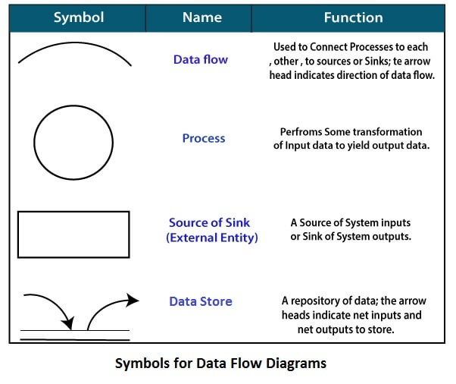

**Circle:** A circle (bubble) shows a process that transforms data inputs into data outputs.

**Data Flow:** A curved line shows the flow of data into or out of a process or data store.

**Data Store:** A set of parallel lines shows a place for the collection of data items. A data store indicates that the data is stored which can be used at a later stage or by the other processes in a different order. The data store can have an element or group of elements.

**Source or Sink:** Source or Sink is an external entity and acts as a source of system inputs or sink of system outputs.

**Zero Level DFD**

**Changing Password**

**Management**

**Product**

**Management**

**Login Management**

**Booking Management**

**Authorization Management**

**Brand**

**Management**

**User Management**

**Pages**

**Management**

**First Level DFD**

**Admin**

**Password**

**Management**

**Login Management**

**Authorization Management**

**Product**

**Management**

**Brand**

**Management**

**Changing Password**

**Management**

**User Management**

**Booking Management**

**Generate Report**

**Pages**

**Management**

**Second Level DFD**

**Admin**

**Manage Brand**

**Manage Product**

**Manage Pages**

**View Reg Users**

**Manage Booking**

**Change Password**

**Update Profile**

**Search Booking**

**Generate Reports**

**Book Laptop or Desktop**

**User**

**ok**

**View Booking History**

**View Products**

**View About us and contact us page**

**Change Password**

**Update Profile**

**3.2)** **Database Implementation**

MYSQL- MySQL ("My S-Q-L", officially, but also called "My Sequel") is (as of July 2013) the world's second most widely used open-source relational database management system (RDBMS). It is named after co-founder Michael Widenius daughter, My. The SQL phrase stands for Structured Query Language. The MySQL development project has made its source code available under the terms of the GNU General Public License, as well as under a variety of proprietary agreements. MySQL was owned and sponsored by a single for-profit firm, the Swedish company MySQL AB, now owned by Oracle Corporation .MySQL is a popular choice of database for use in web applications, and is a central component of the widely used LAMP opens source web application software stack (and other 'AMP' stacks). LAMP is an acronym for "Linux, Apache, MySQL, Perl/PHP/Python." Free-software-open source projects that require a full-featured database management system often use MySQL. For commercial use, several paid editions are available, and offer additional functionality. Applications which use MySQL databases Library Management System include: TYPO3, MODx, Joomla, WordPress, phpBB, MyBB, Drupal and other software. MySQL is also used in many high-profile, large-scale websites, including Wikipedia, Google (though not for searches), Facebook, Twitter, Flickr, and YouTube.

**Database tables**

In this project various tables used for maintain the information.

[**tbladmin**](http://localhost/phpmyadmin/sql.php?db=camsdb&token=0cdfa1f46252d35aec9fa851dd4c03bb&goto=db_structure.php&table=tbladmin&pos=0) **:** This table use to store admin login details.

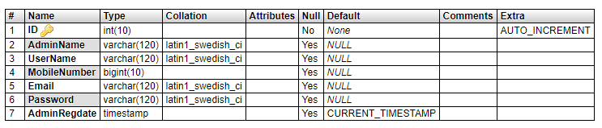

[**tblbrand**](http://localhost/phpmyadmin/sql.php?db=camsdb&token=0cdfa1f46252d35aec9fa851dd4c03bb&goto=db_structure.php&table=tbladmin&pos=0) **:** This table use to store brand details.

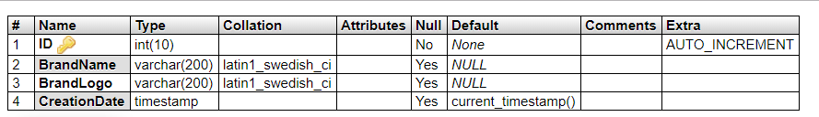

**tbluser:** This table use to store user details.

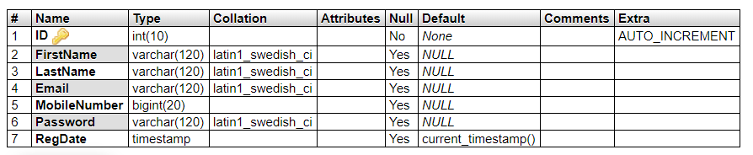

**tblproduct :** This table use to store laptop and desktops details.

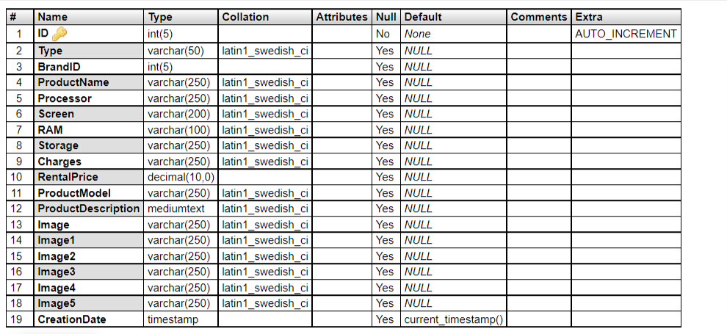

**tblbooking :** This table use to store laptop and desktops booking details.

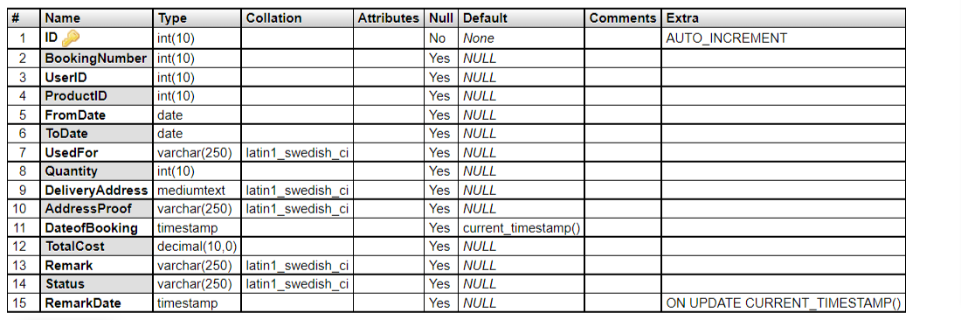

**tblpage:** This table use to store pages info details.

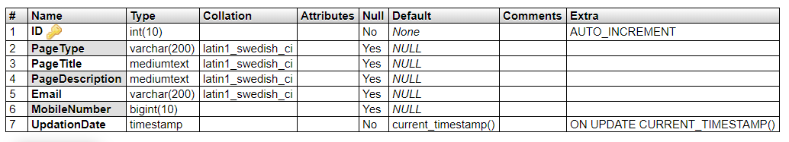

#### 3.3) ENTITY-RELATIONSHIP Diagrams

#### 

E-R (Entity-Relationship) Diagram is used to represents the relationship between entities in the table.

The symbols used in E-R diagrams are:

SYMBOL PURPOSE

Represents Entity sets.

Represent attributes.

Represent Relationship Sets.

Line represents flow

Structured analysis is a set of tools and techniques that the analyst.

To develop a new kind of a system:

The traditional approach focuses on the cost benefit and feasibility analysis, Project management, and hardware and software selection a personal considerations.

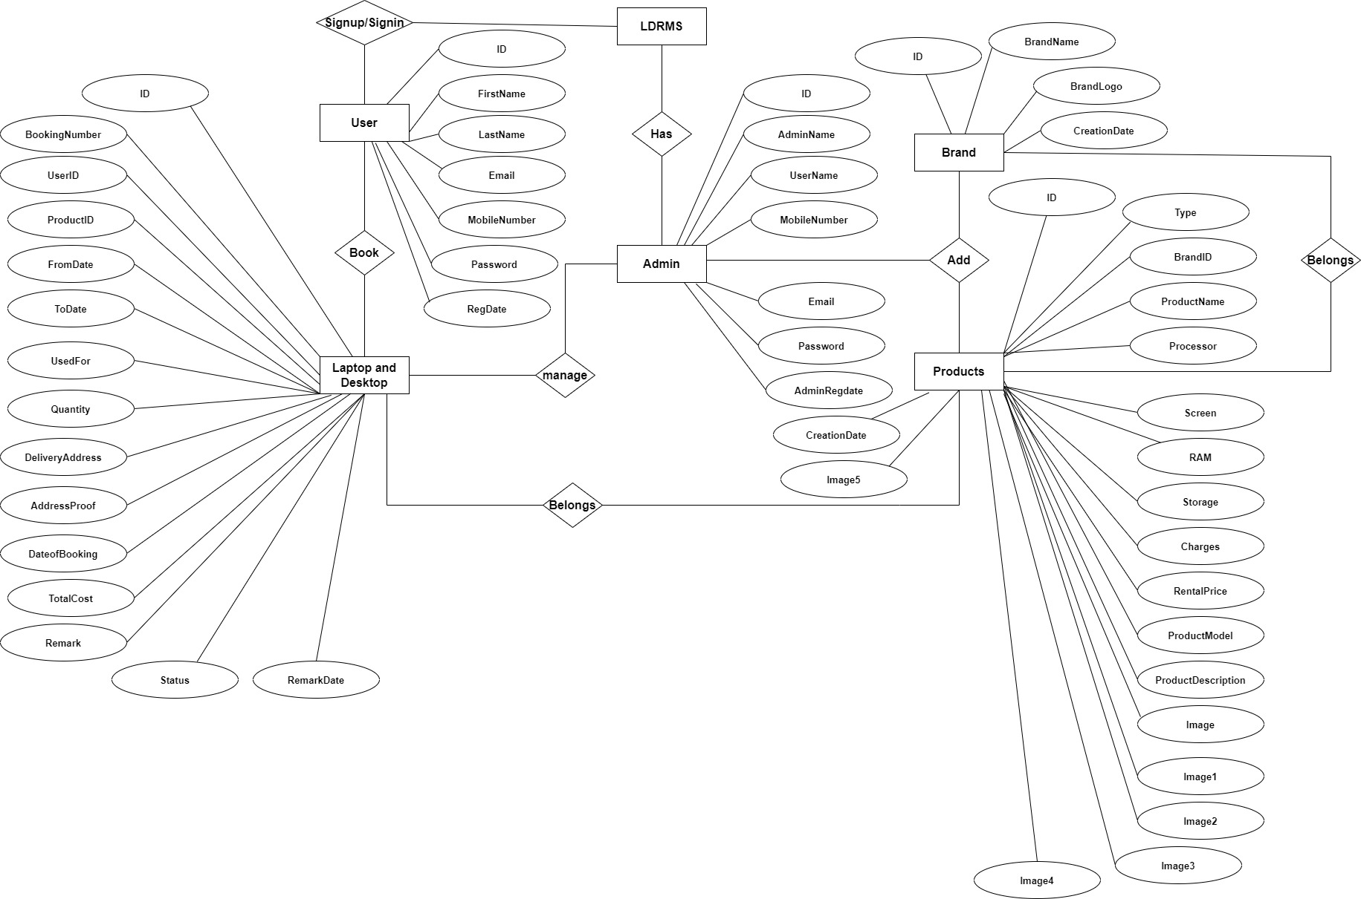

**3.4) Class Diagram:**

The class diagram shows a set of classes, interfaces, collaborations and their relationships.

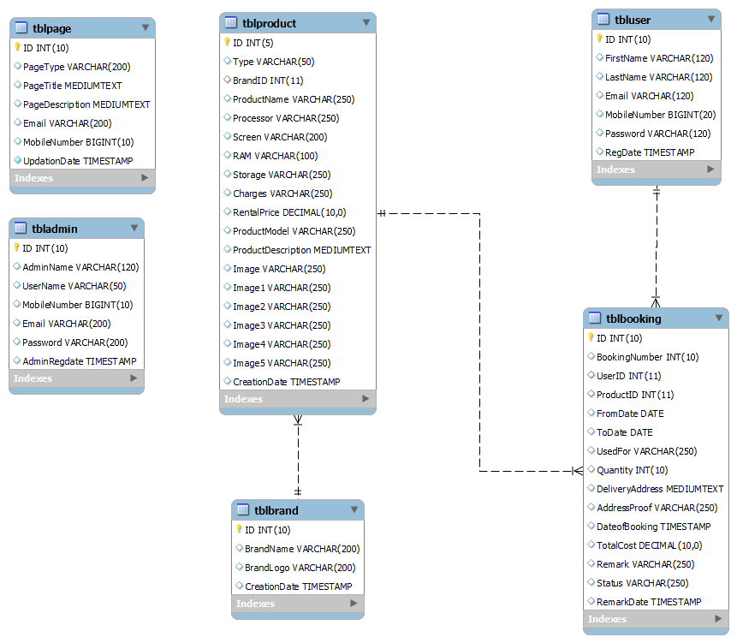

**3.5) Use Case flow Diagram (User)**

**Use Case flow Diagram (Admin)**

**USER MANUAL**

**4.1 USER INTERFACE DESIGN**

**Output Screen of Project**

**Home Page**

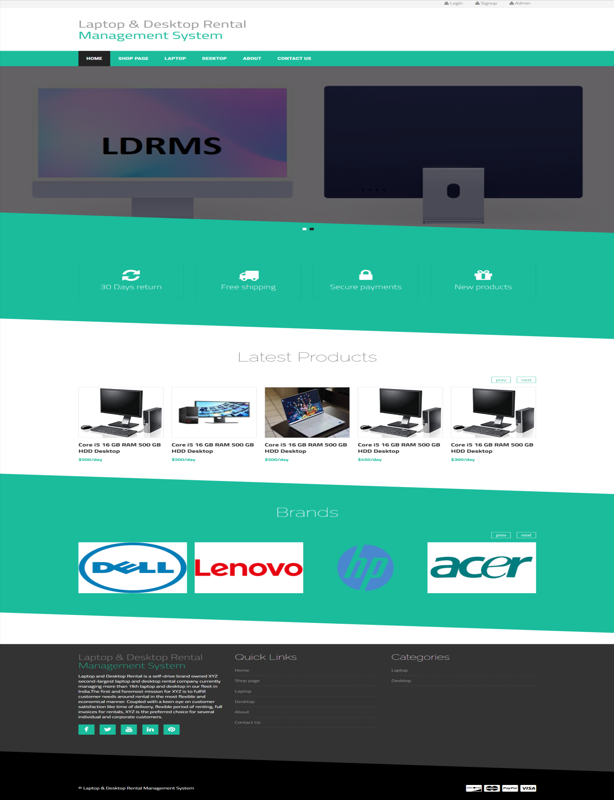

**Shop Page**

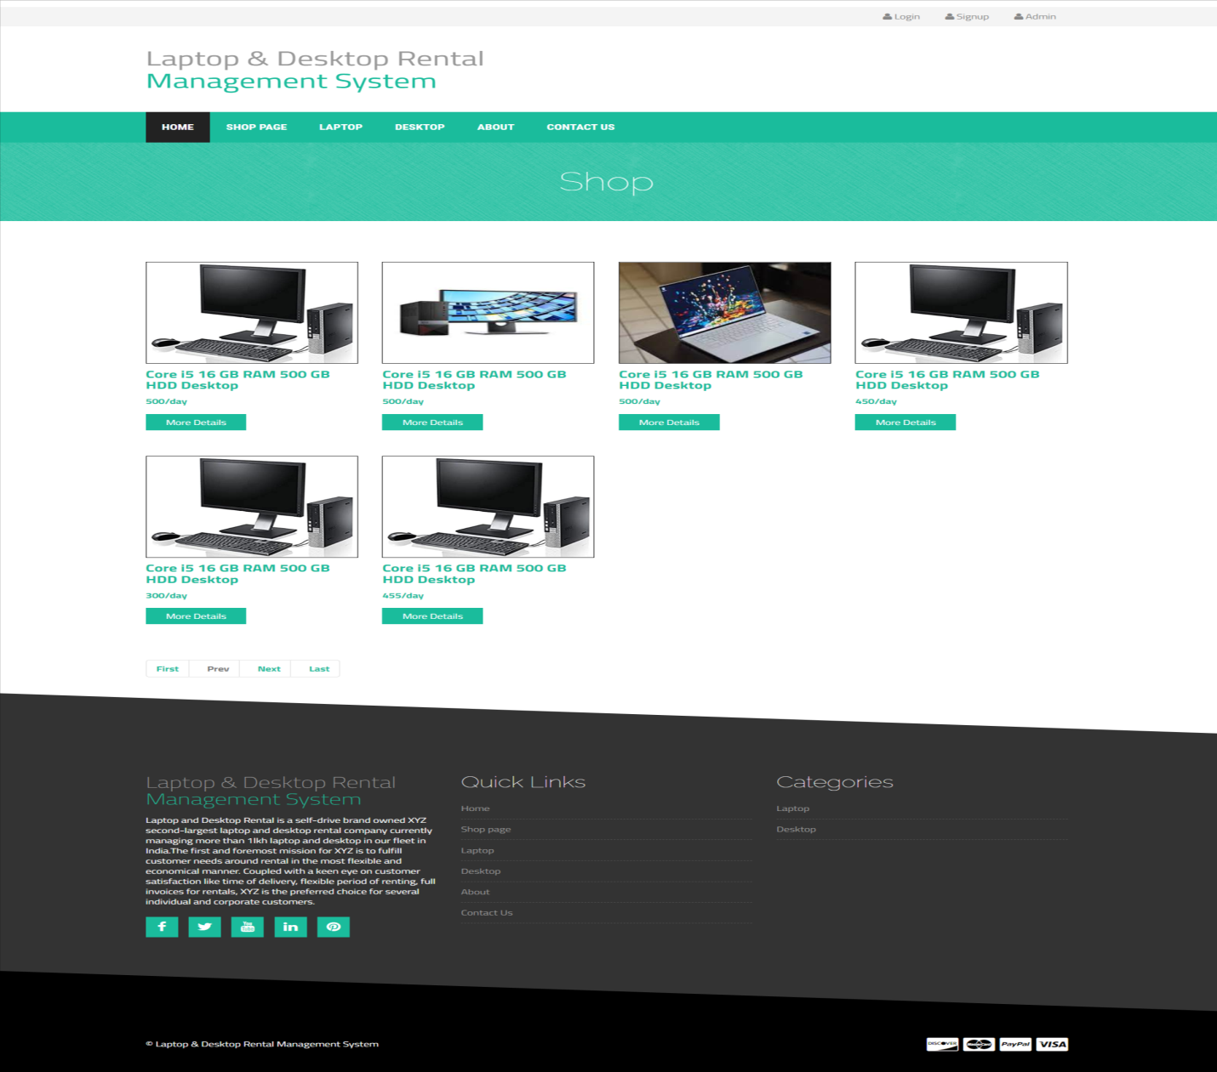

**Laptop Page**

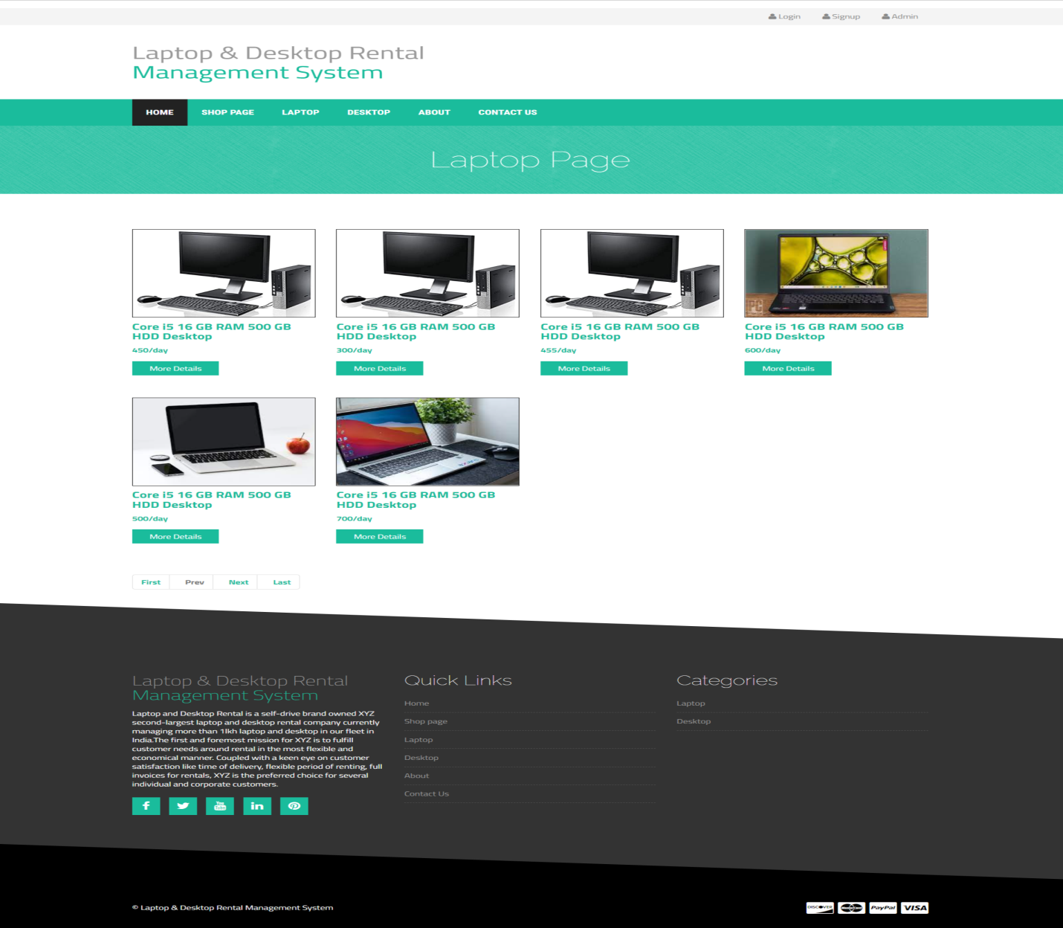

**Desktop Page**

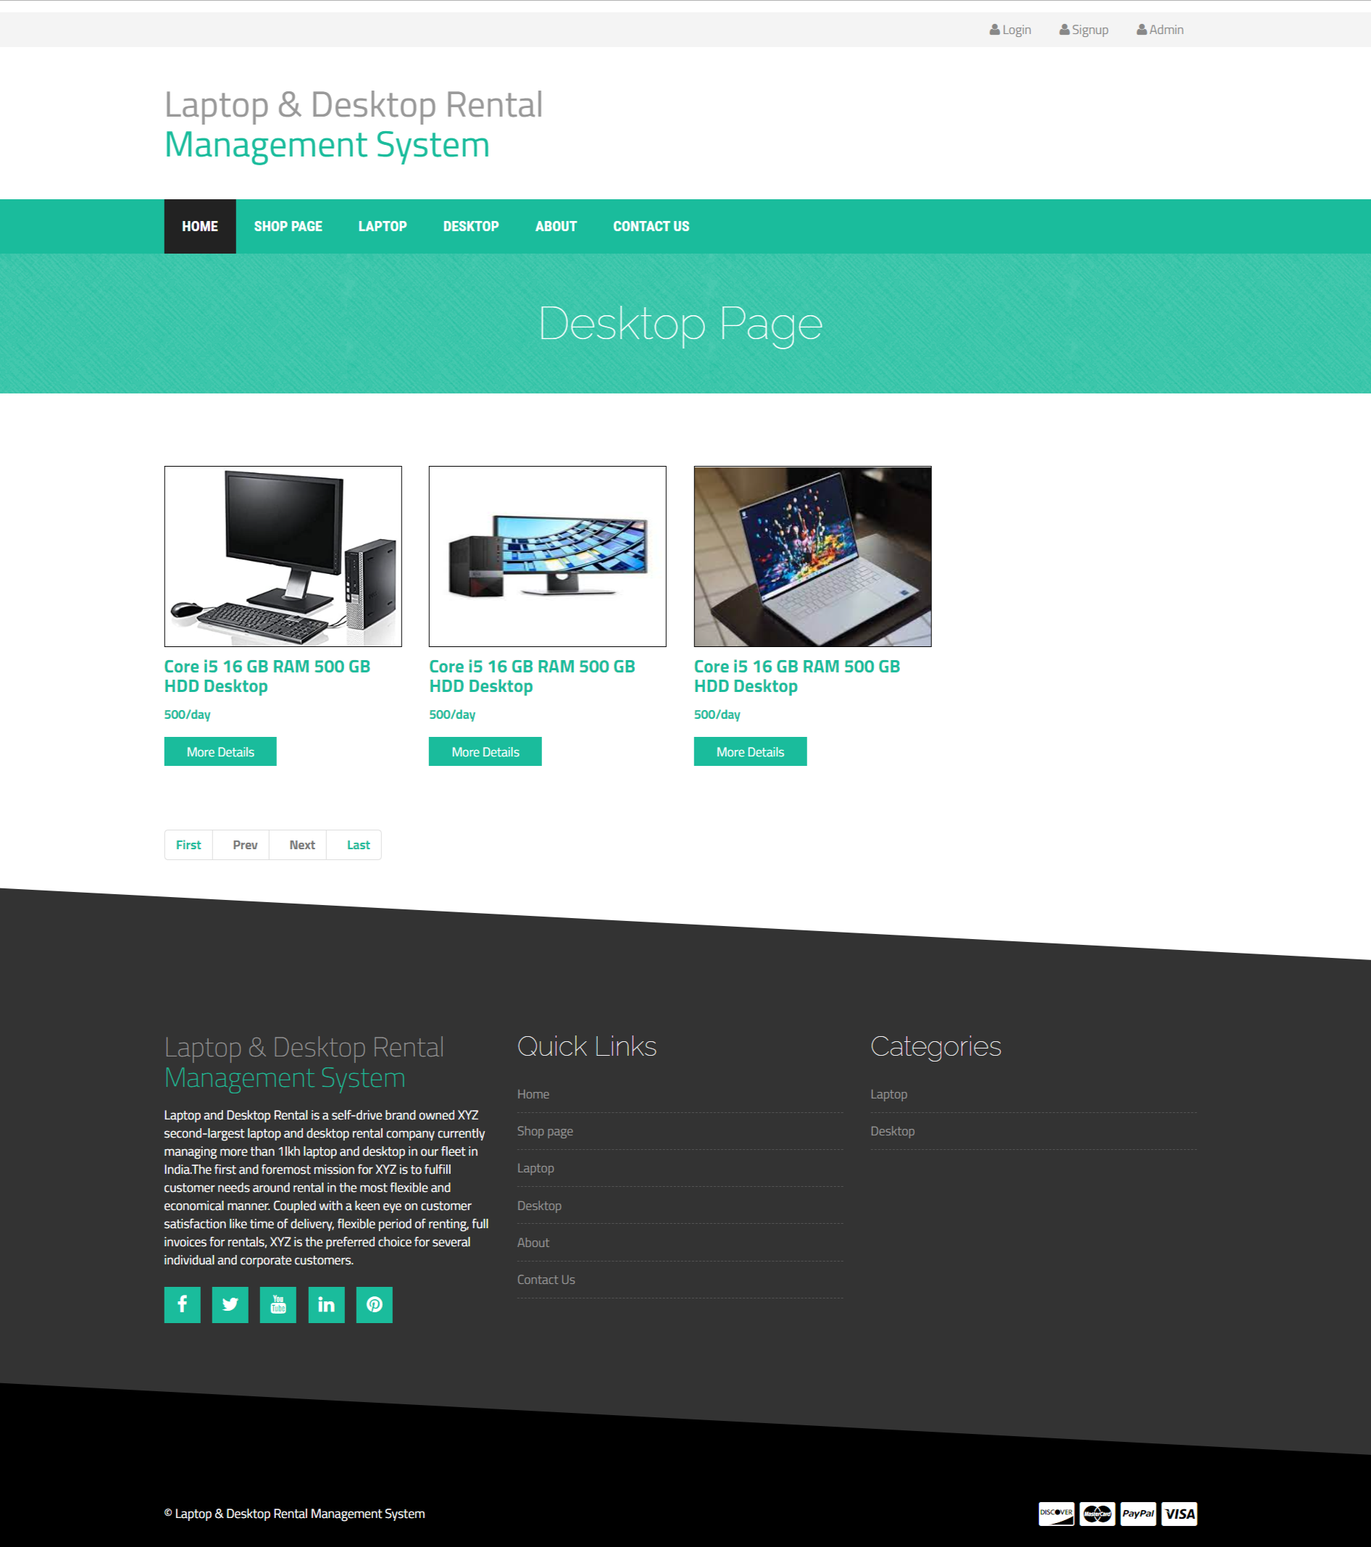

**About Us**

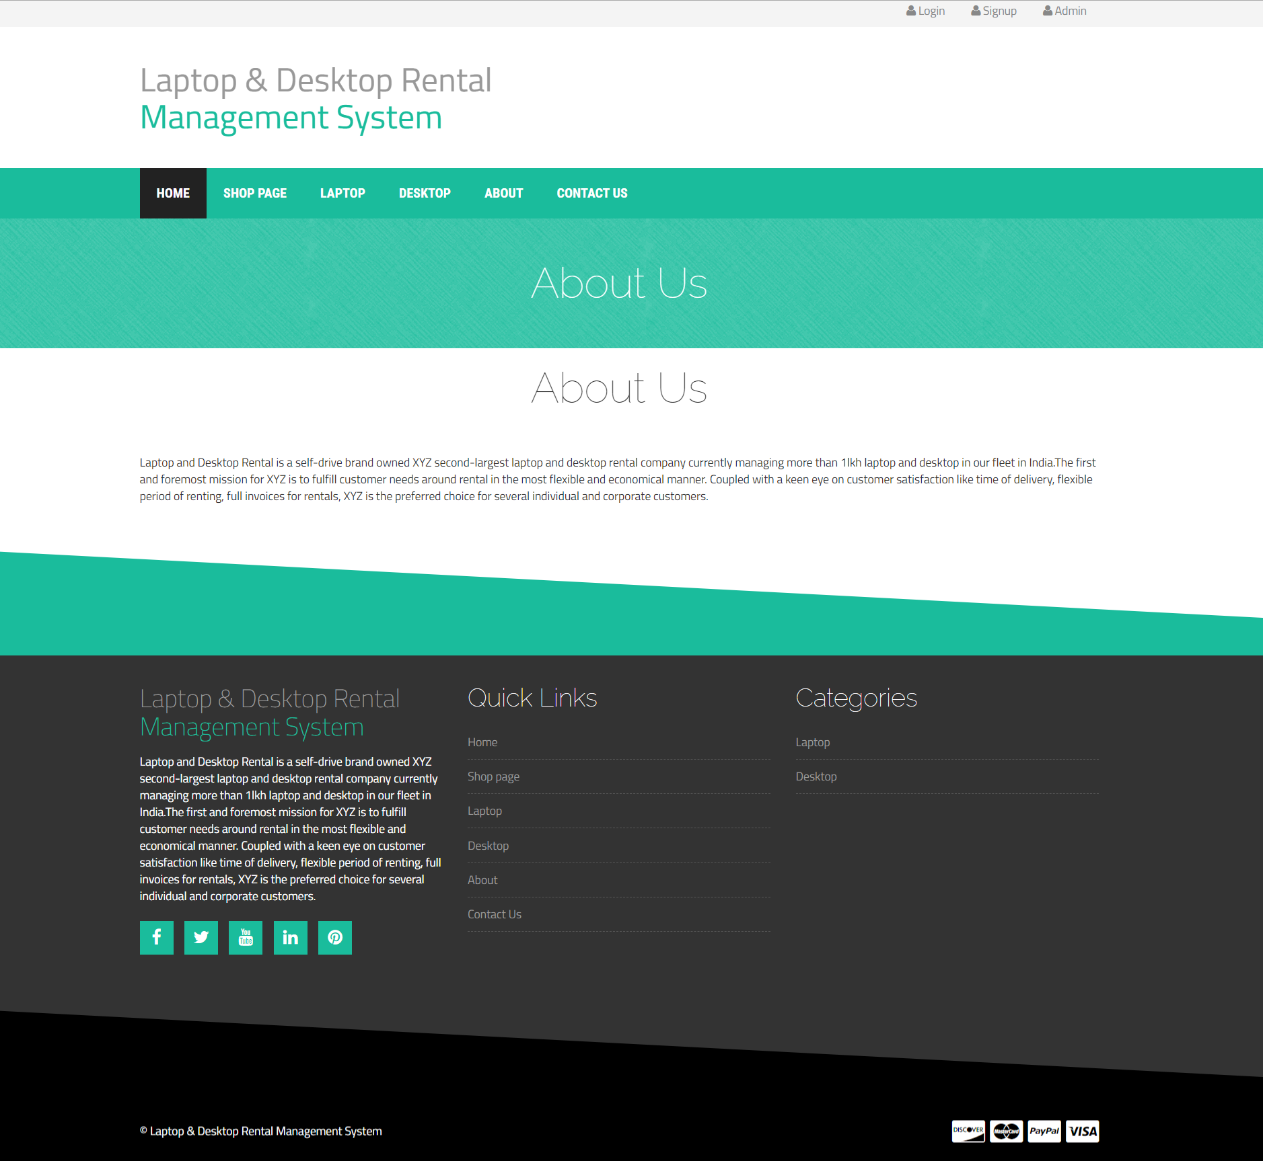

**Contact Us**

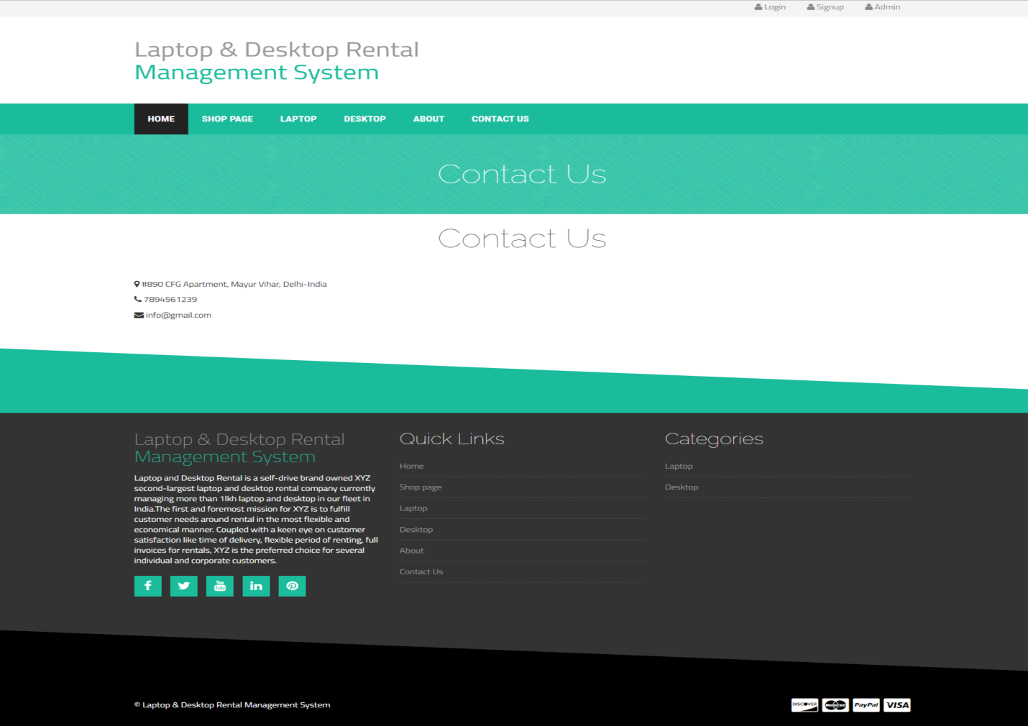

**User Signup**

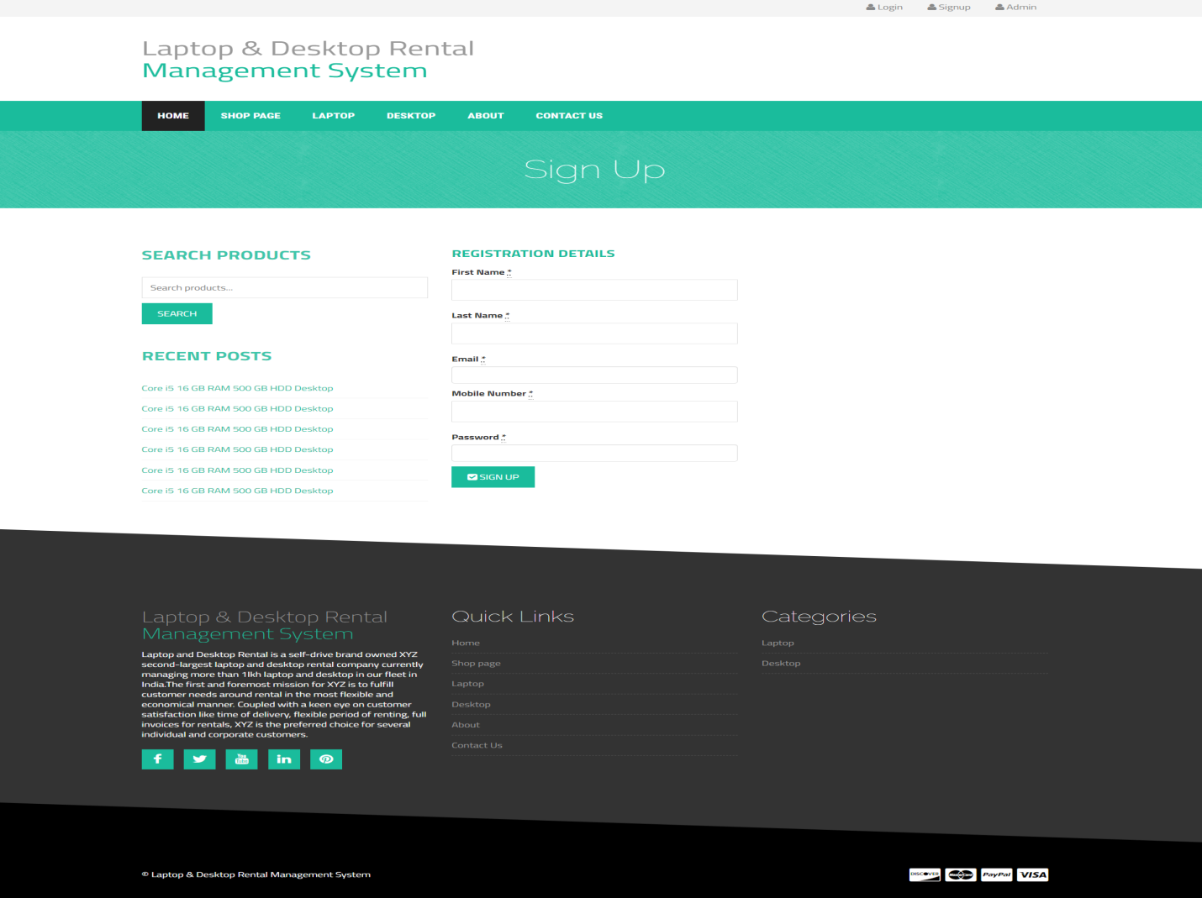

**User Login**

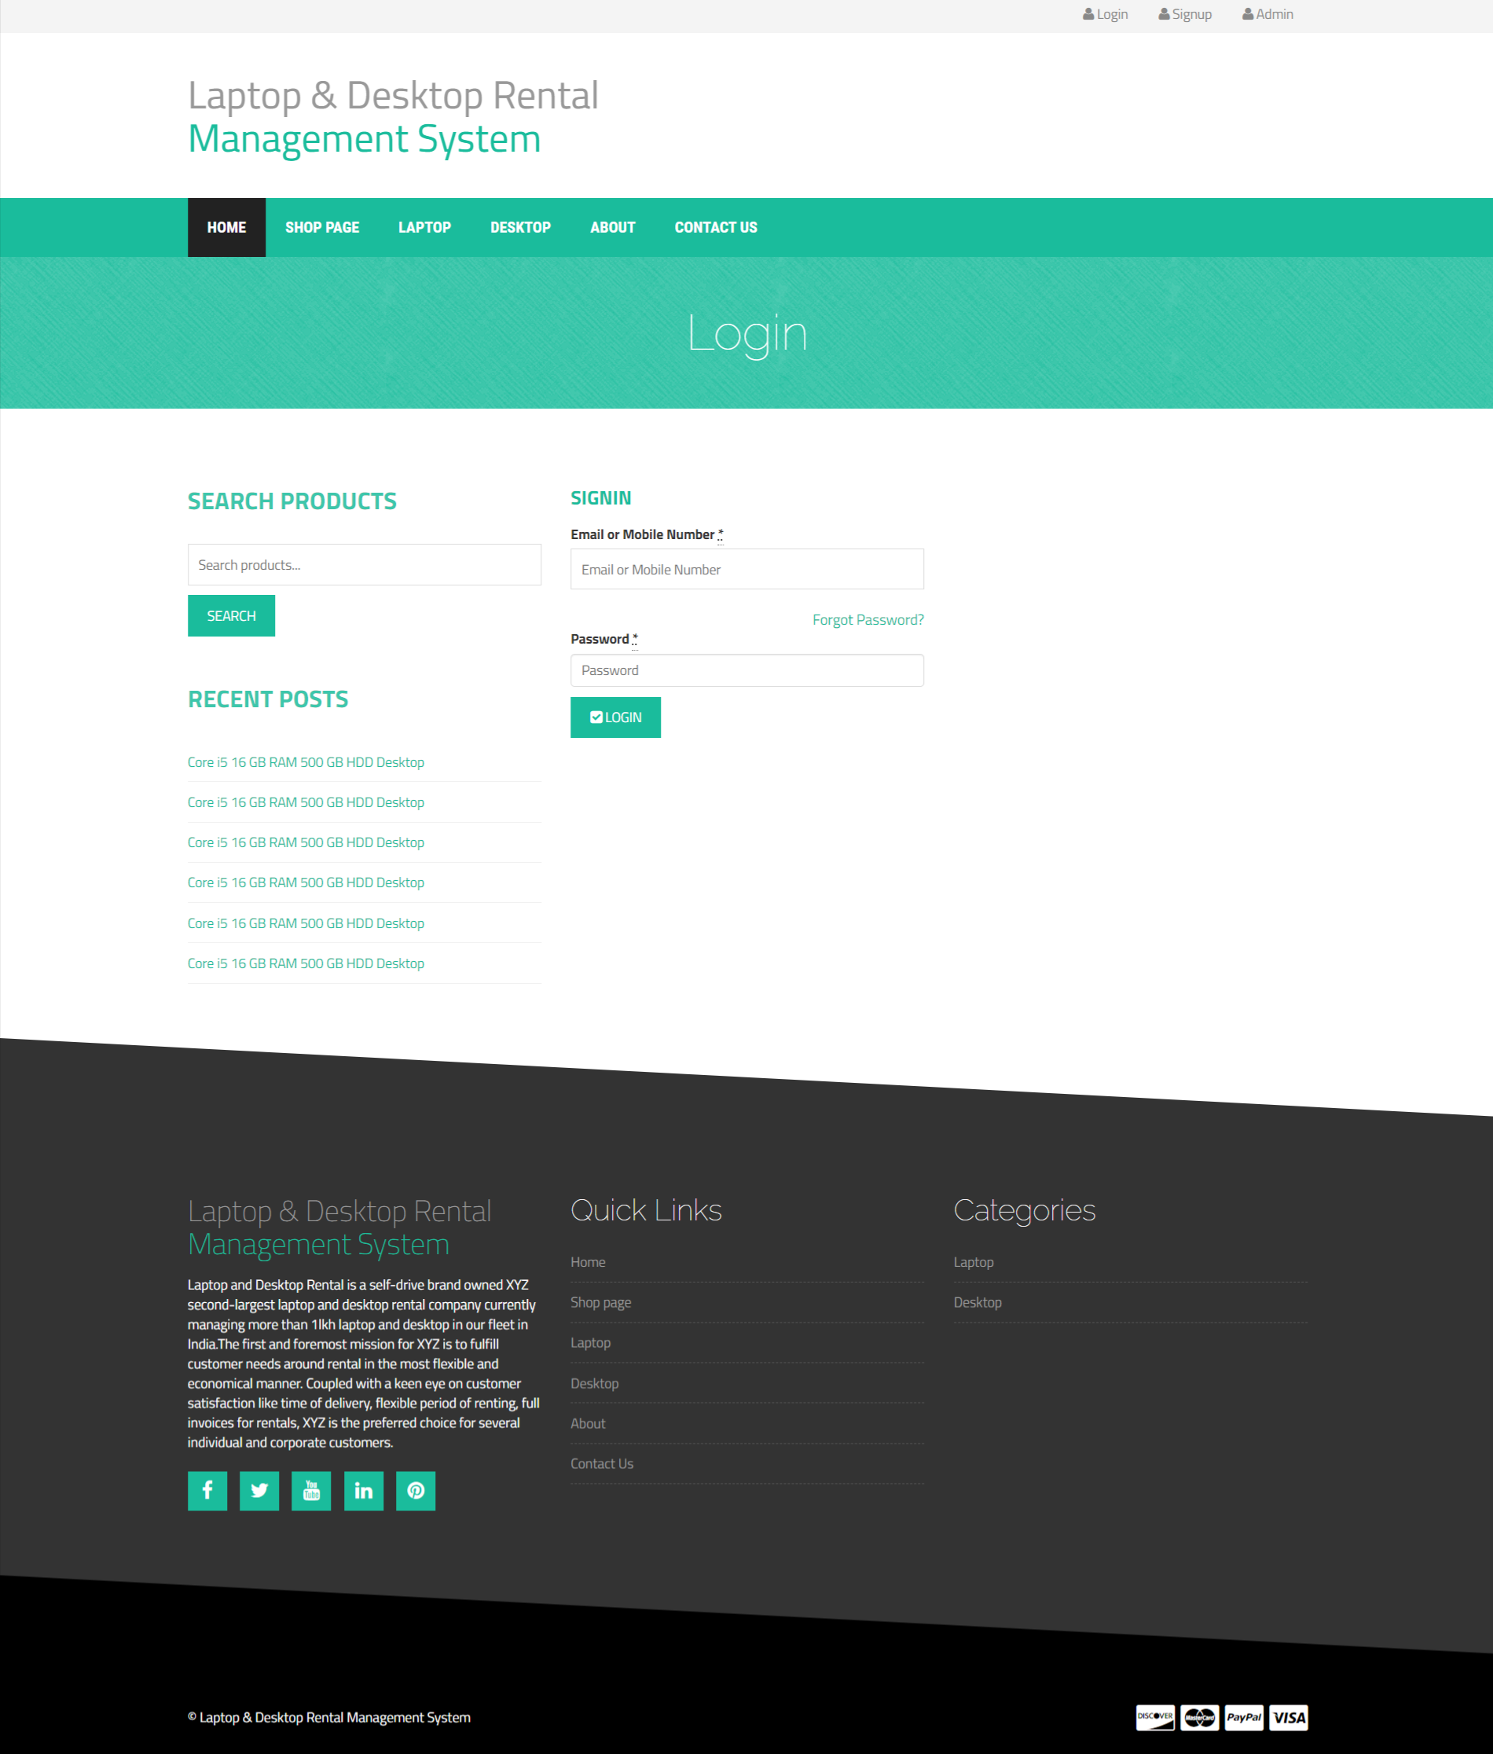

**Forgot Password**

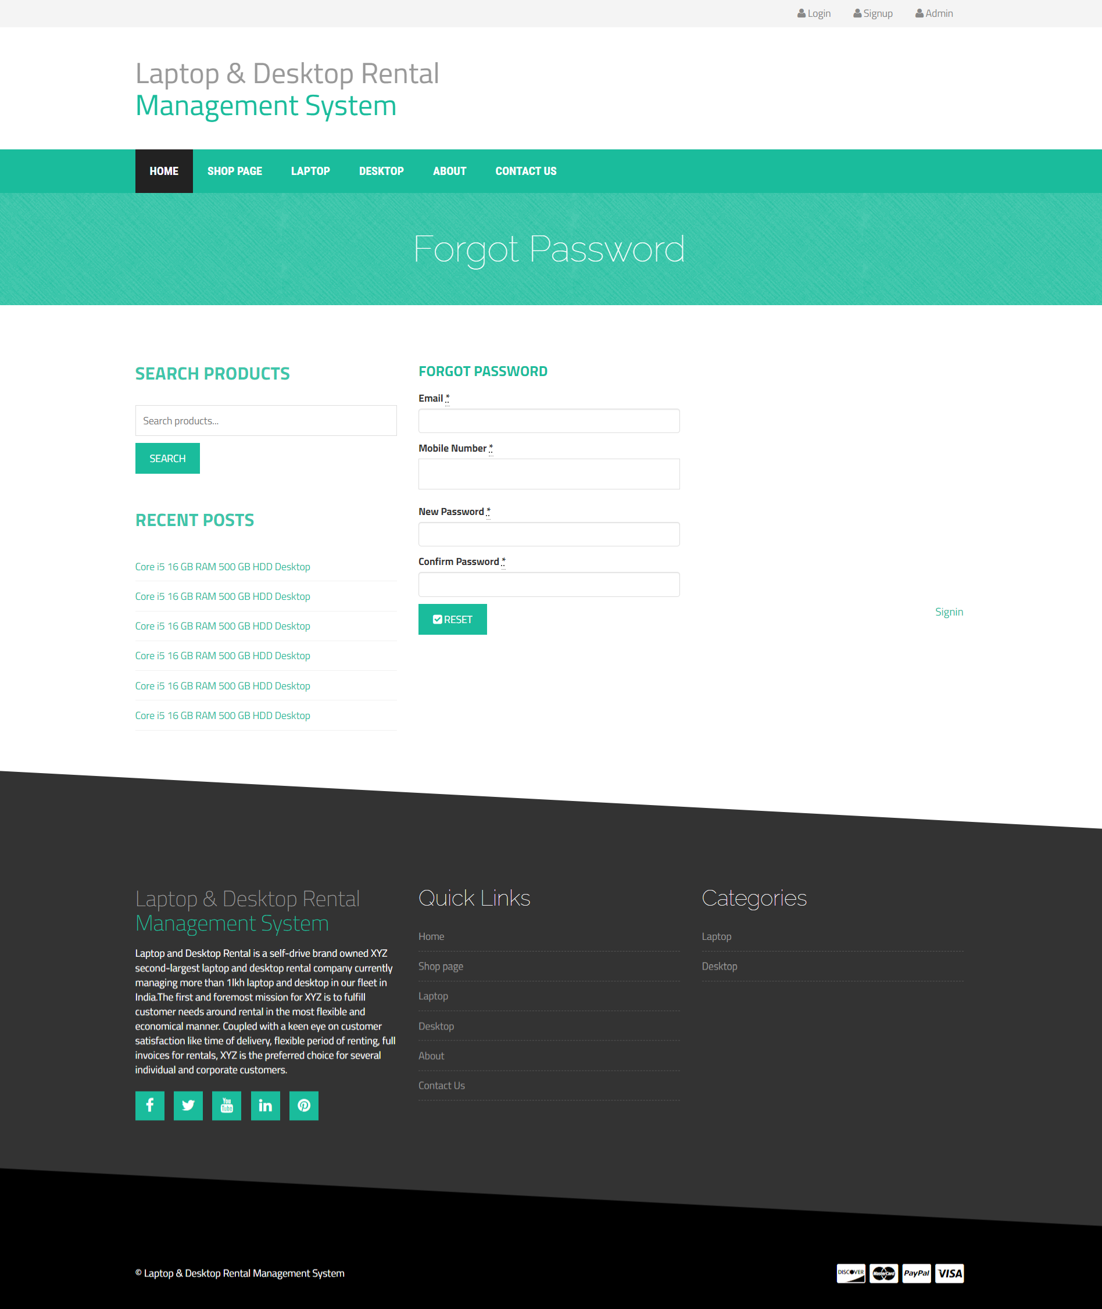

**User Profile**

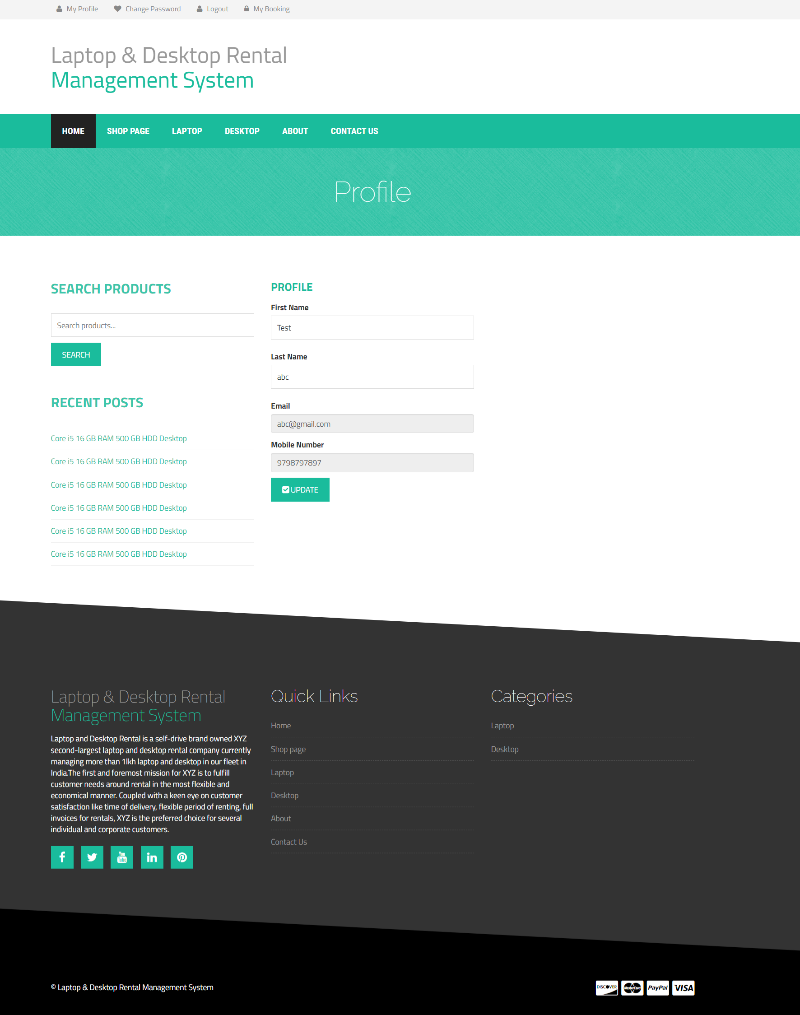

**Change Password**

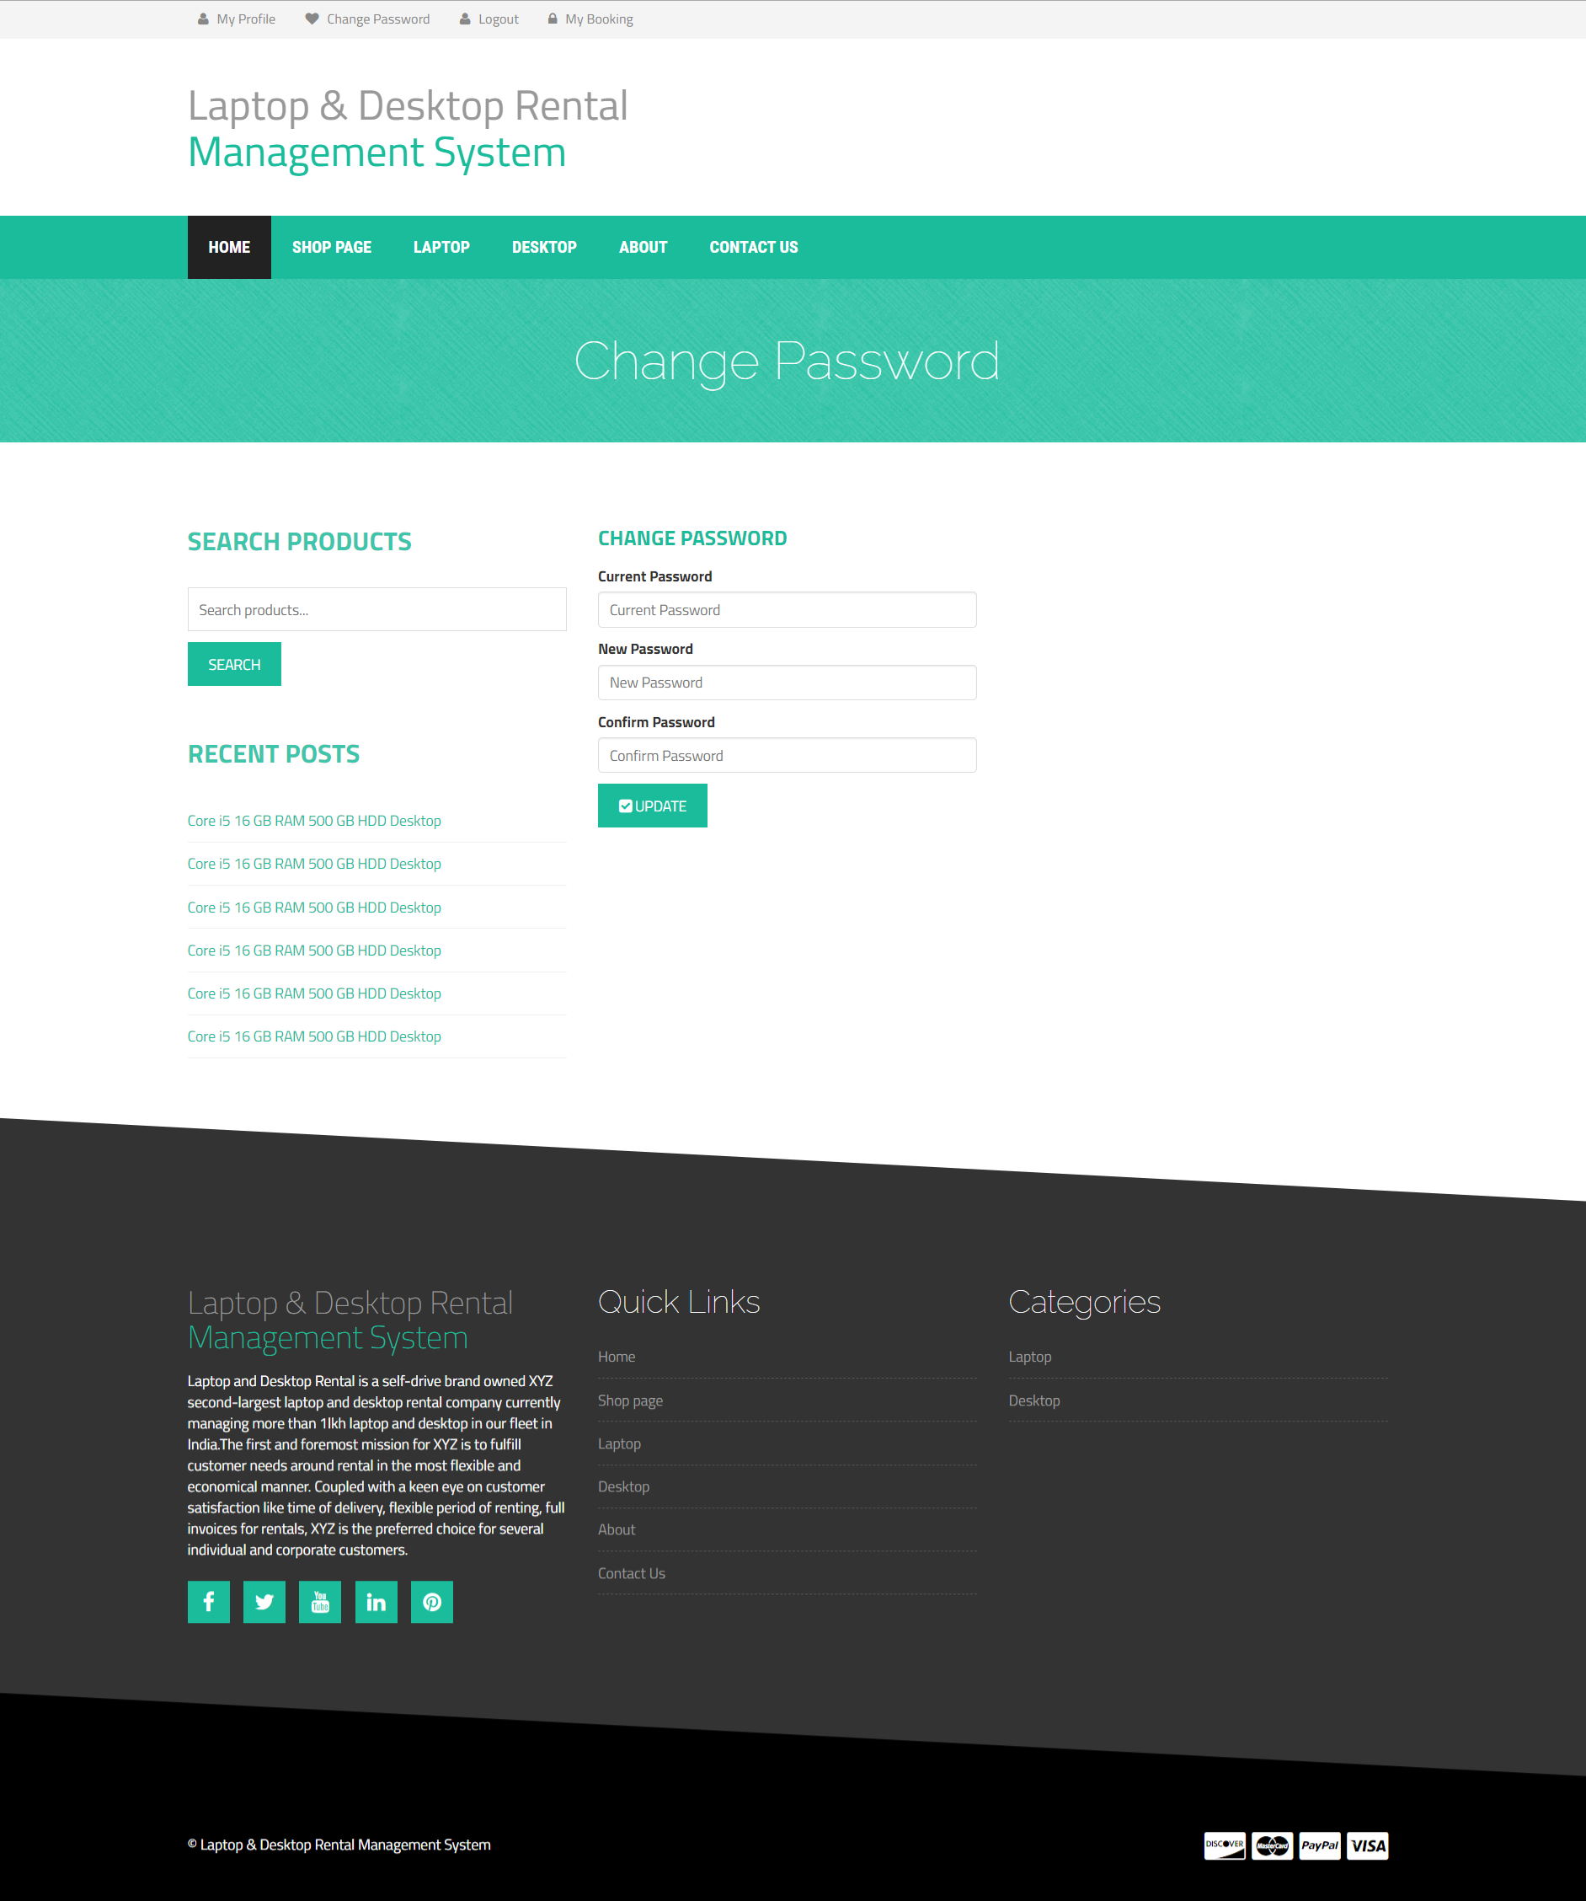

**My Booking**

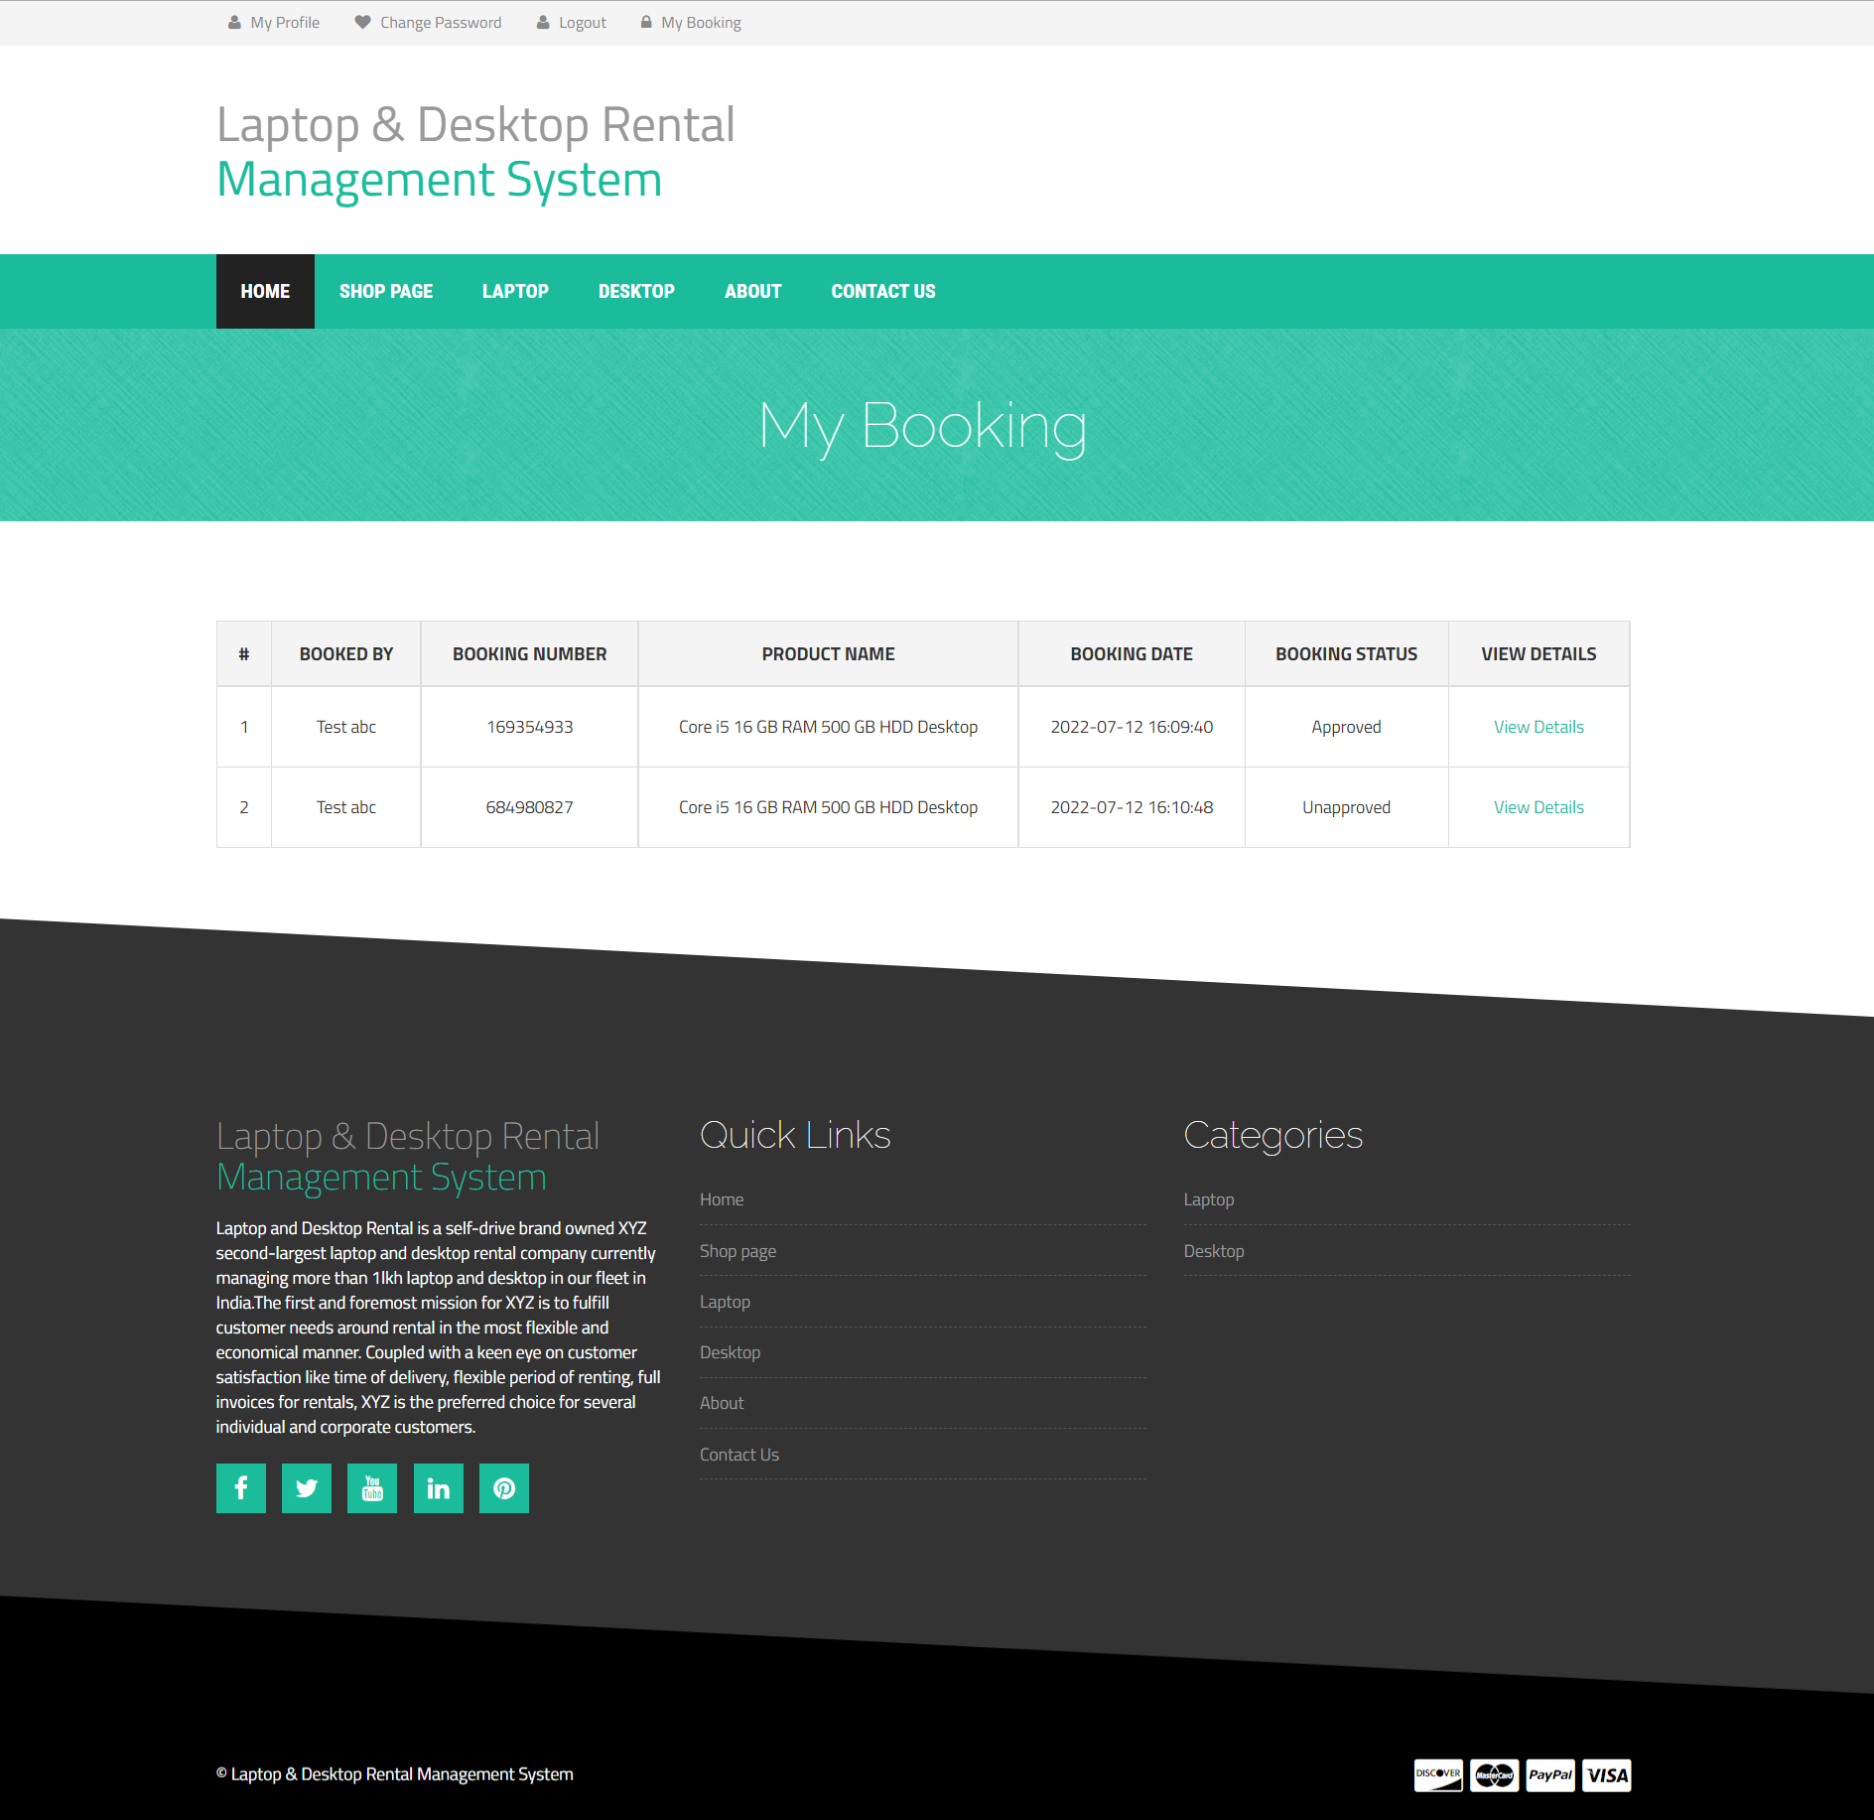

**View Booking Details**

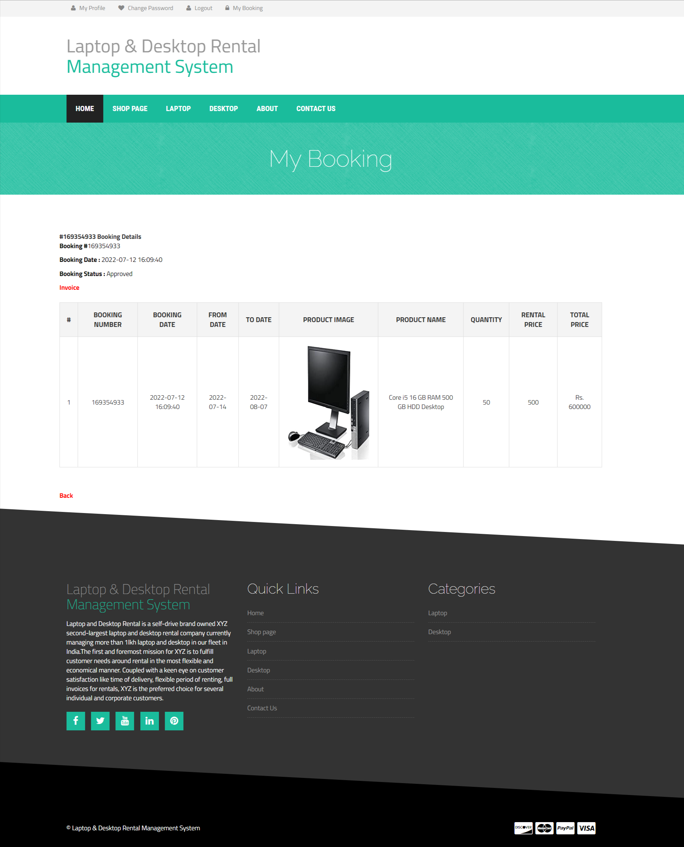

**Invoice** 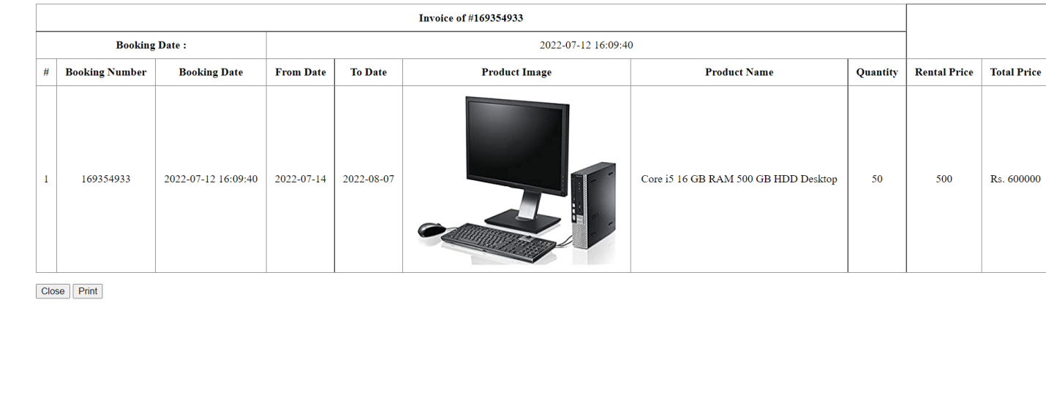

**Admin Login**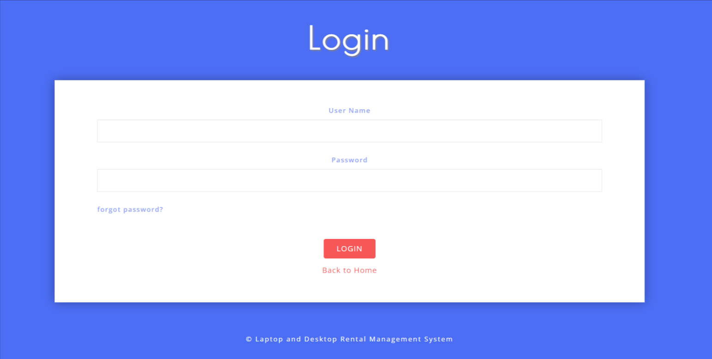

**Dashboard**

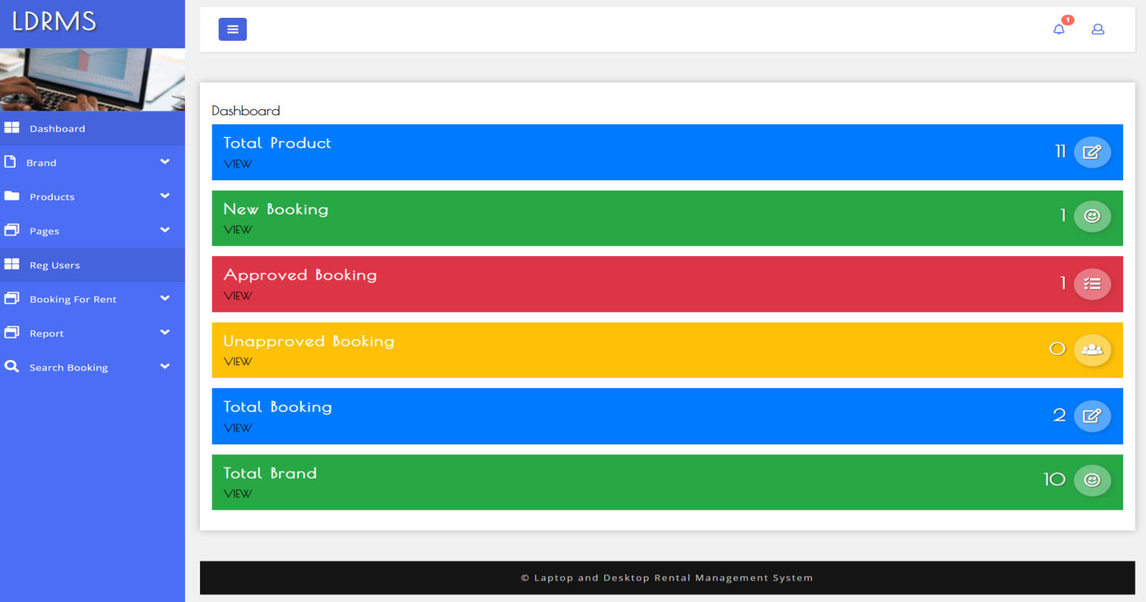

**Admin Profile**

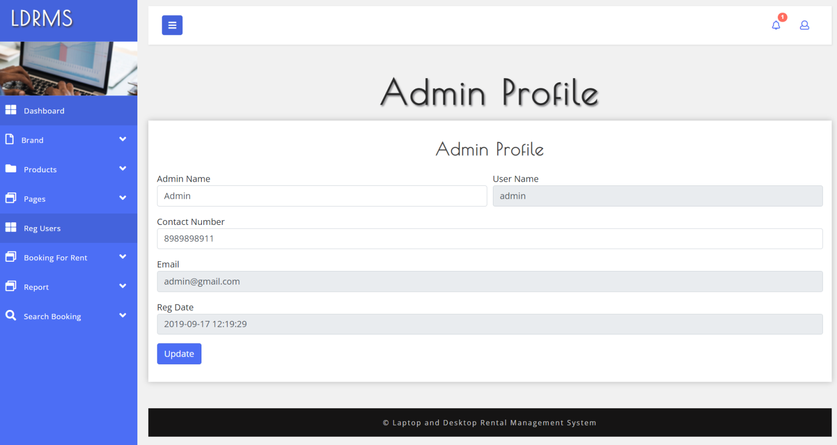

**Change Password**

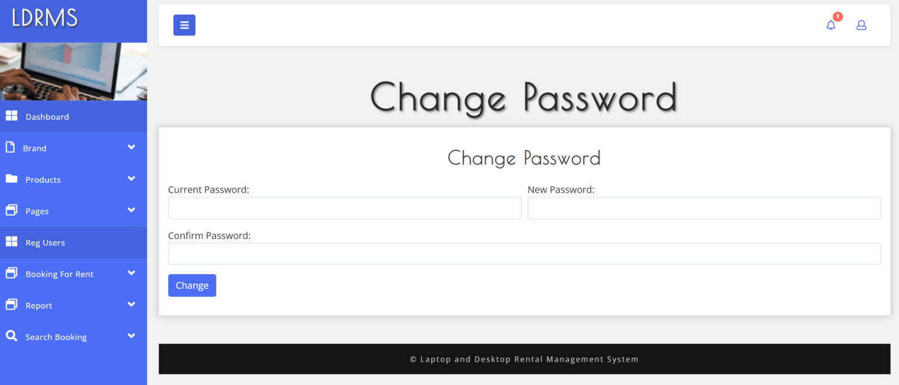

**Add Brands**

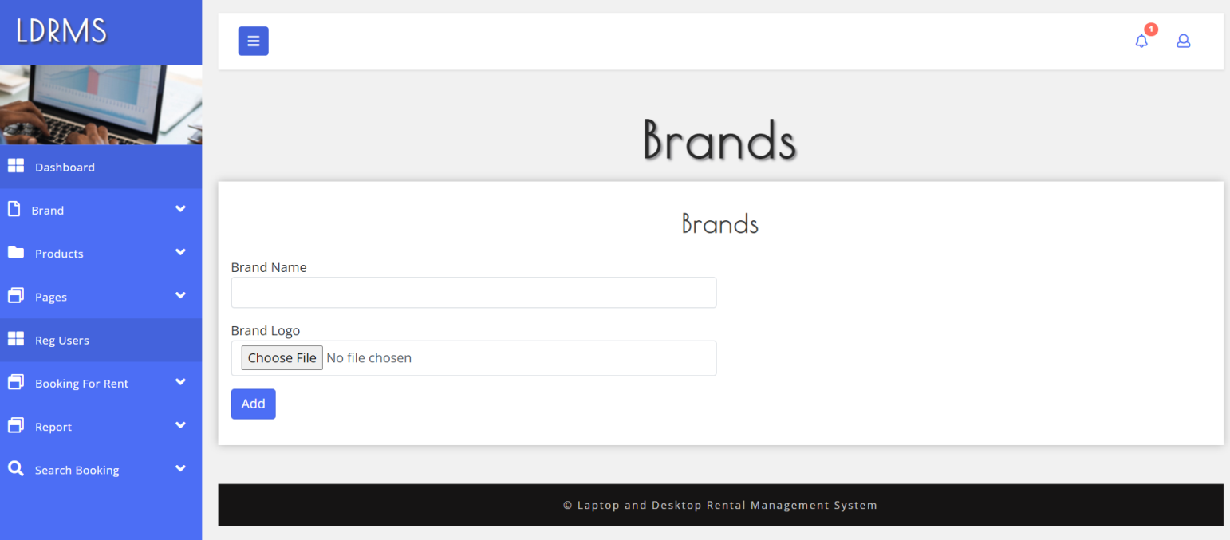

**Manage Brand**

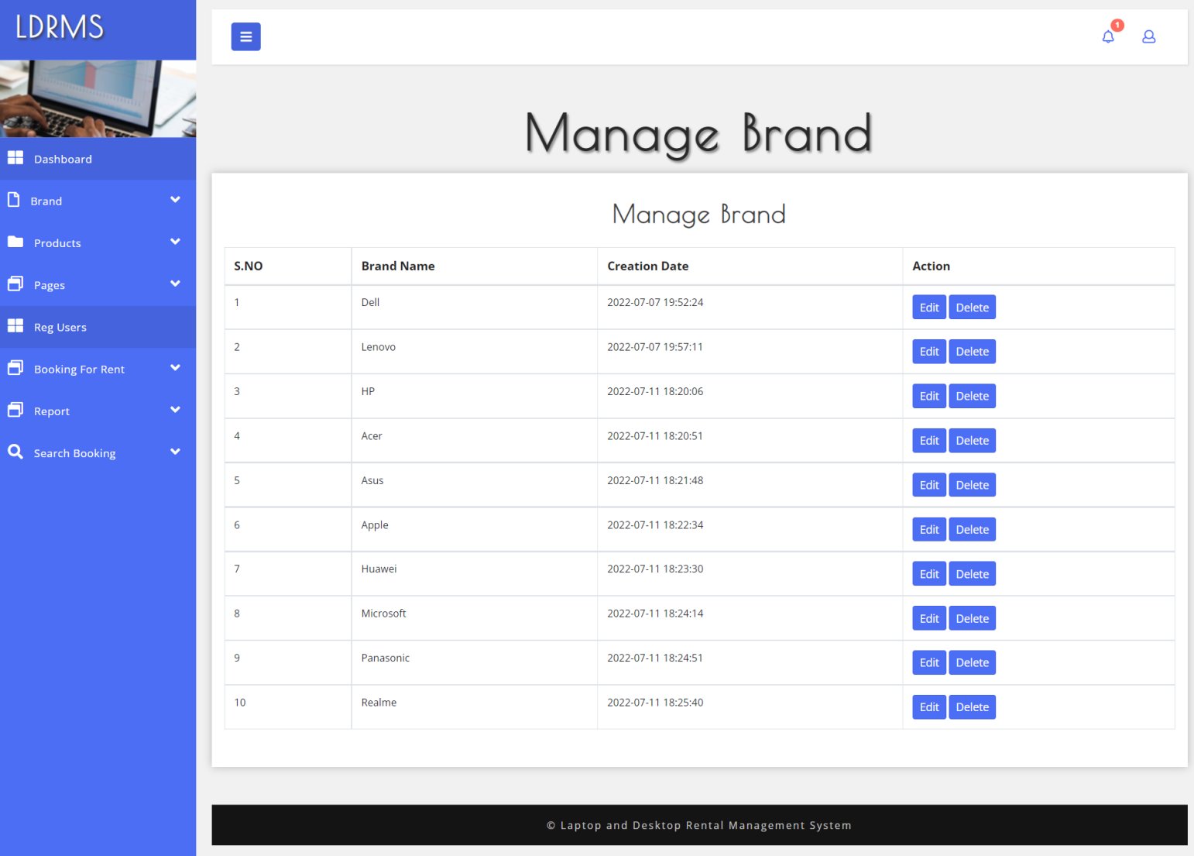

**Update Brand**

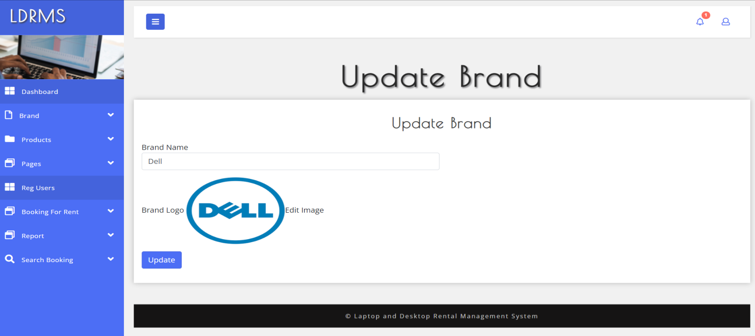

**Add Products**

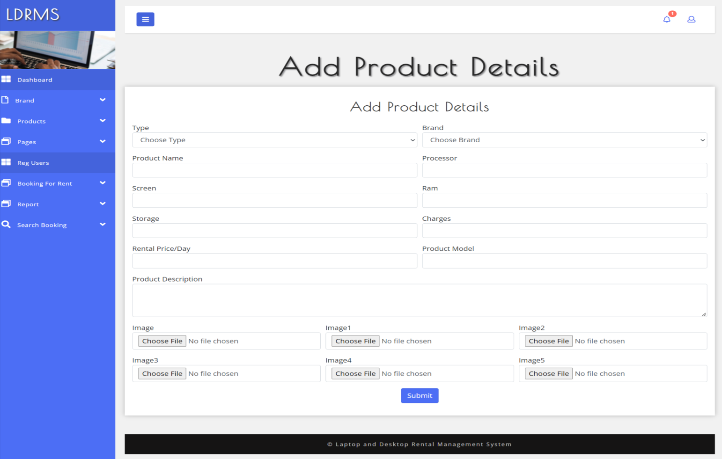

**Manage Products**

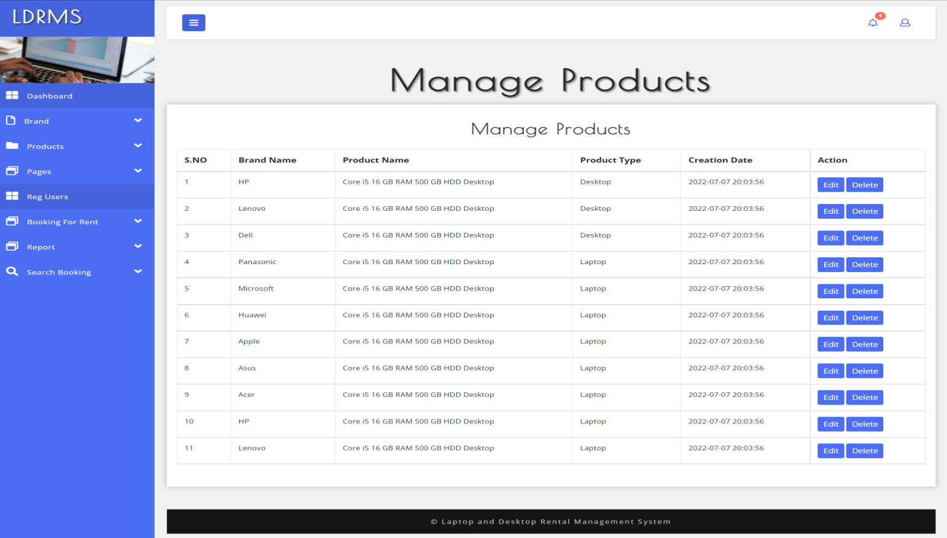

**Update Manage Products**

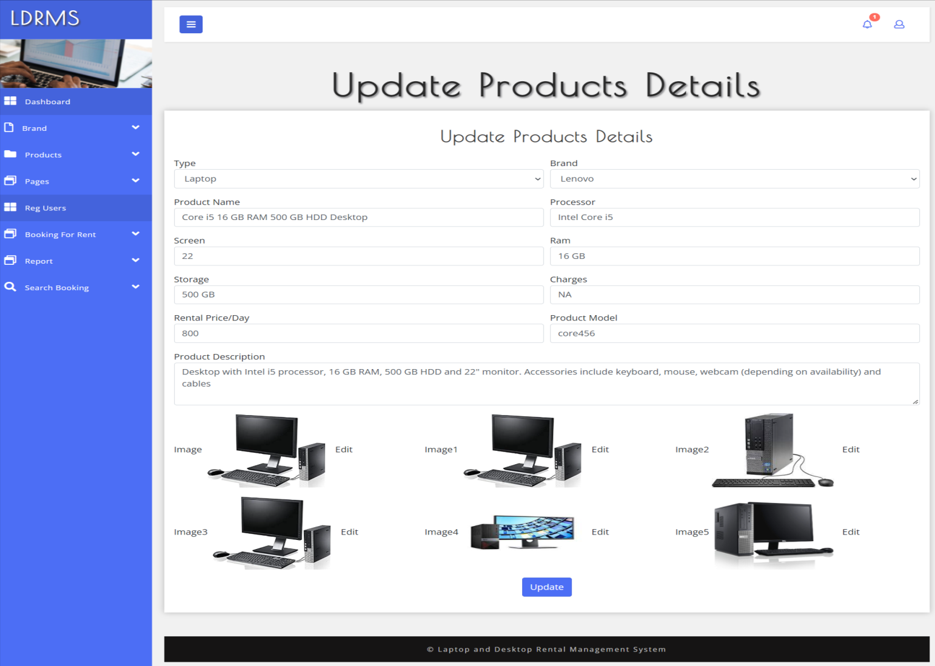

**Update Image**

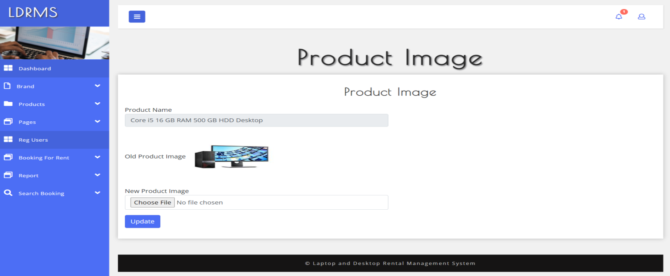

**About us**

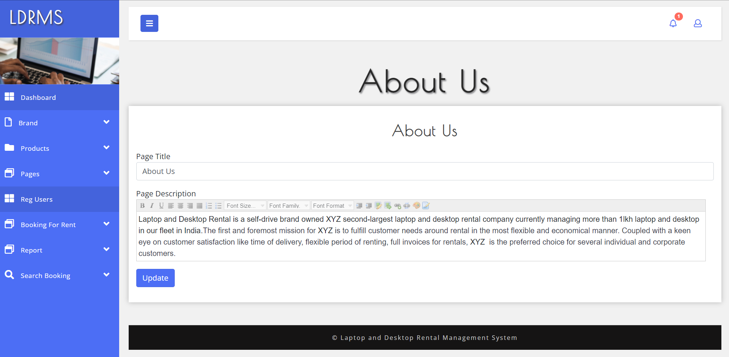

**Contact Us**

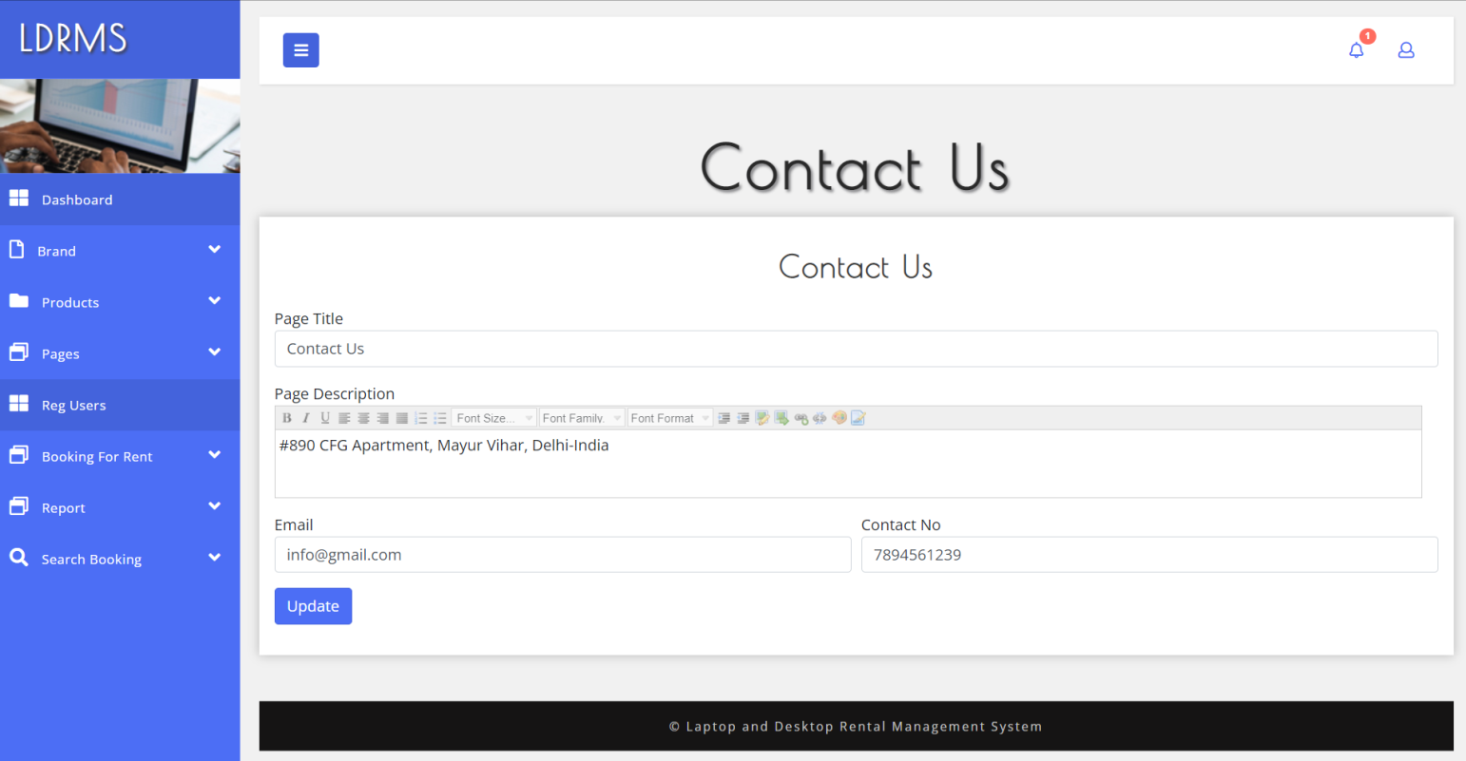

**Register Users**

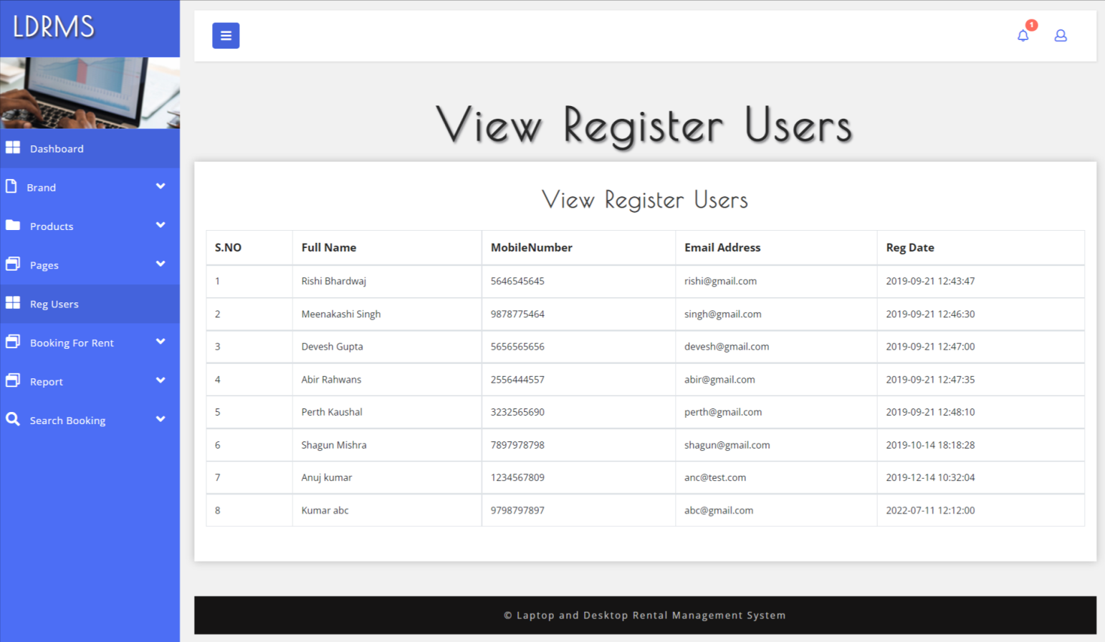

**New Booking**

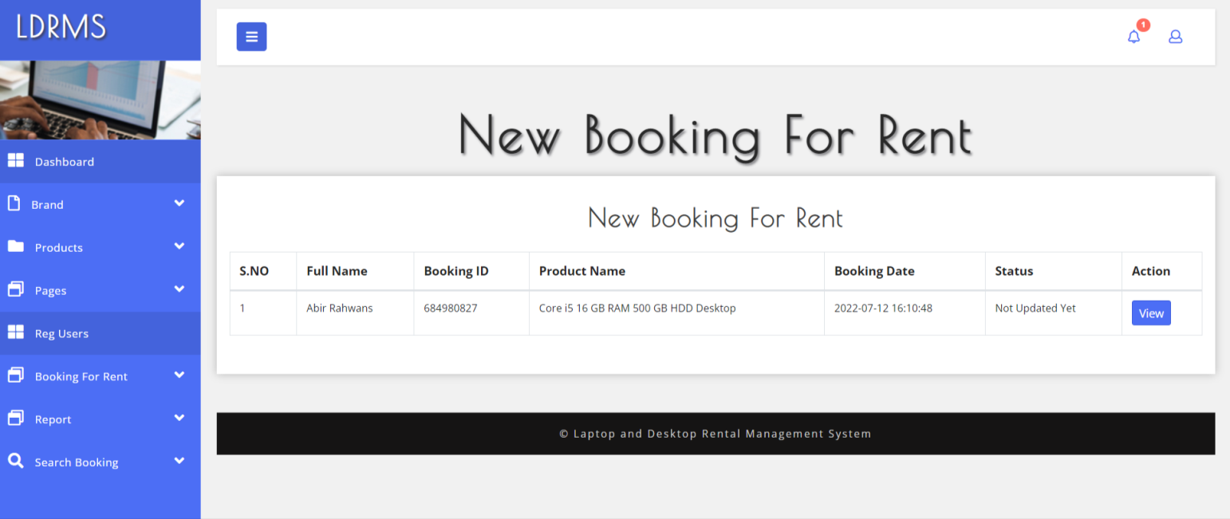

**View New Booking**

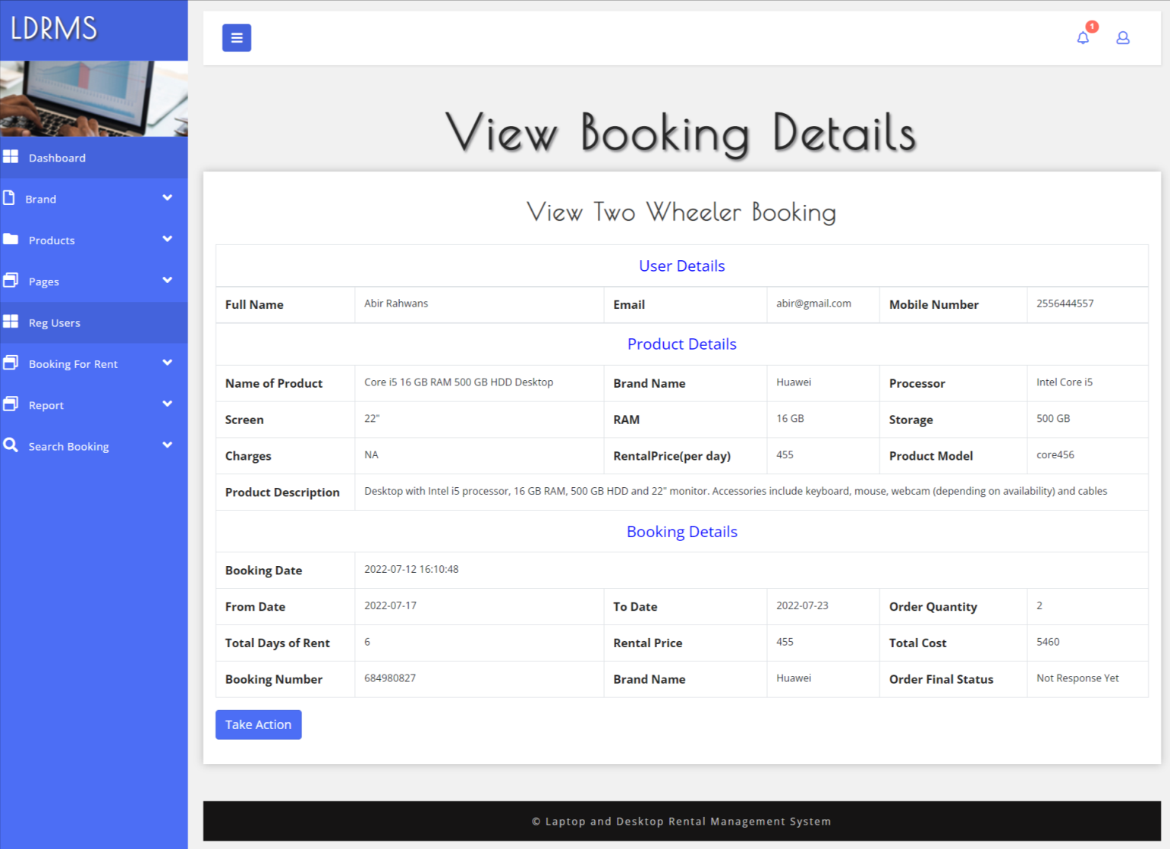

**Approved Booking**

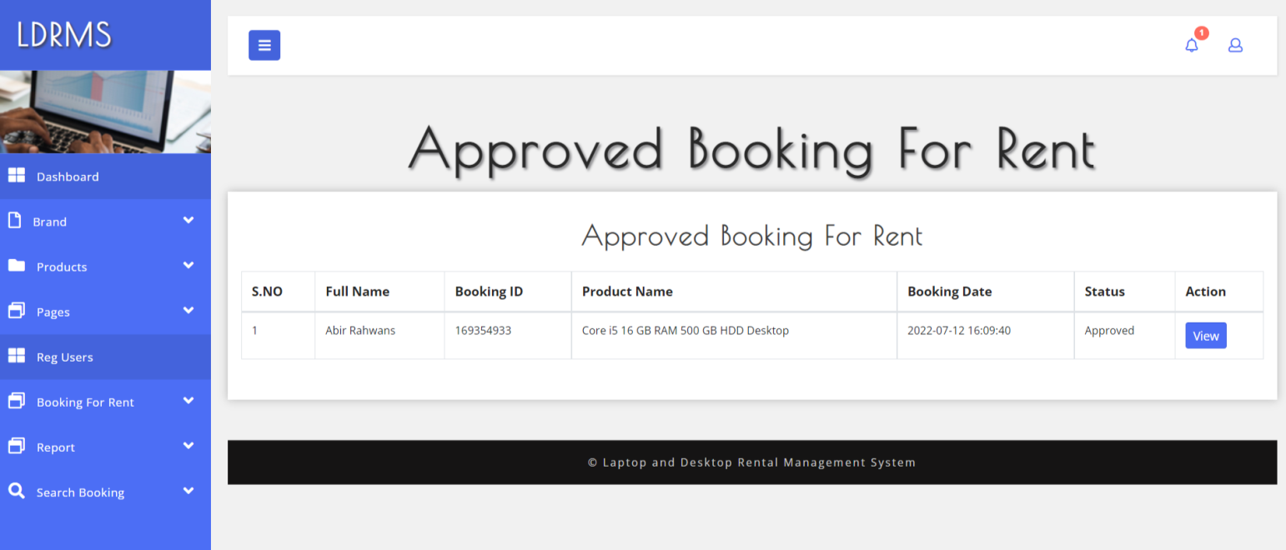

**View Approved Booking**

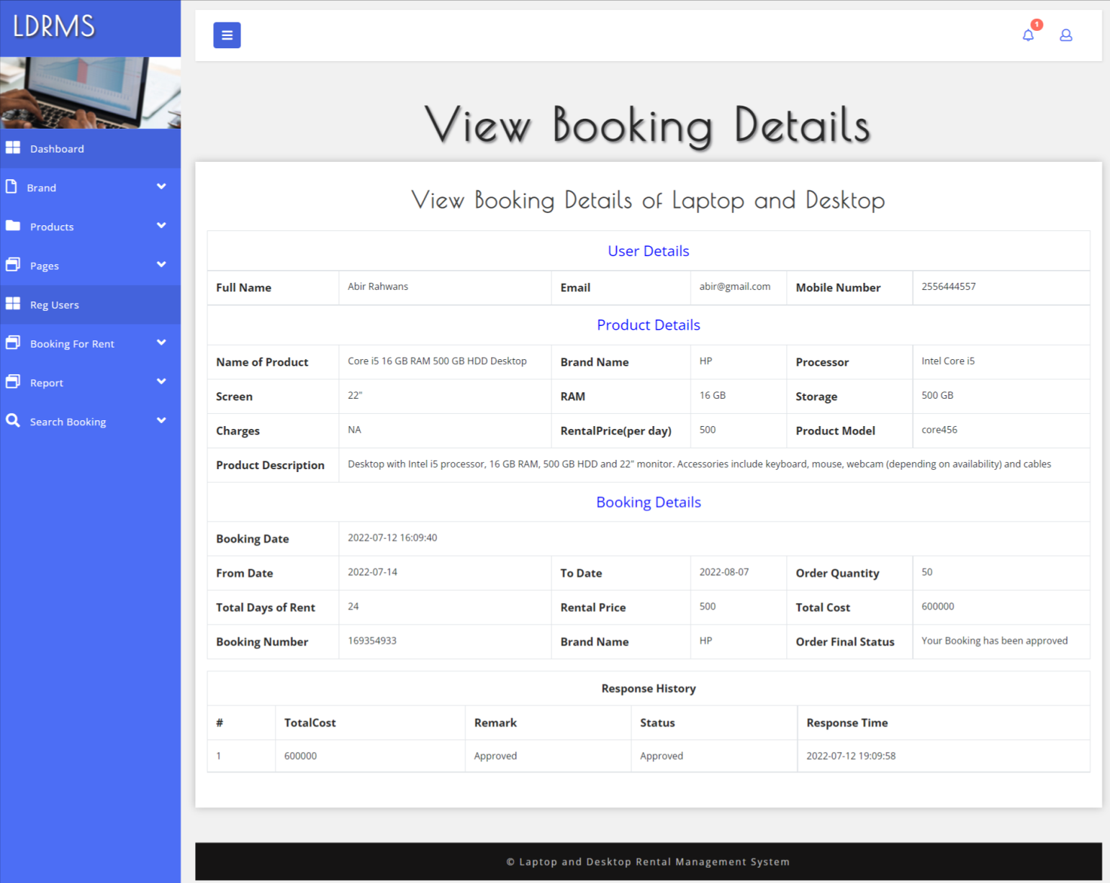

**Unapproved Booking**

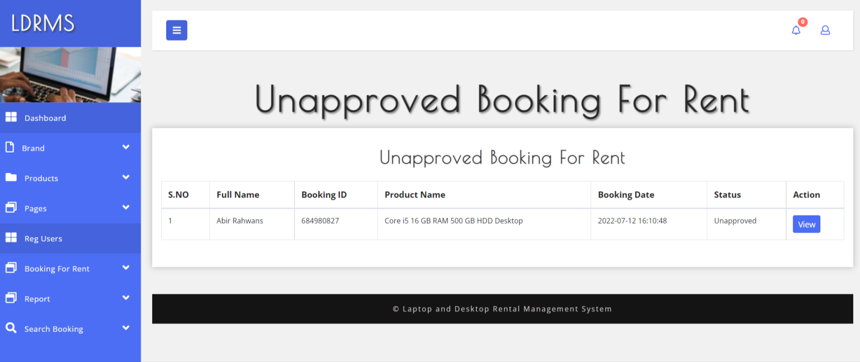

**View Unapproved Booking**

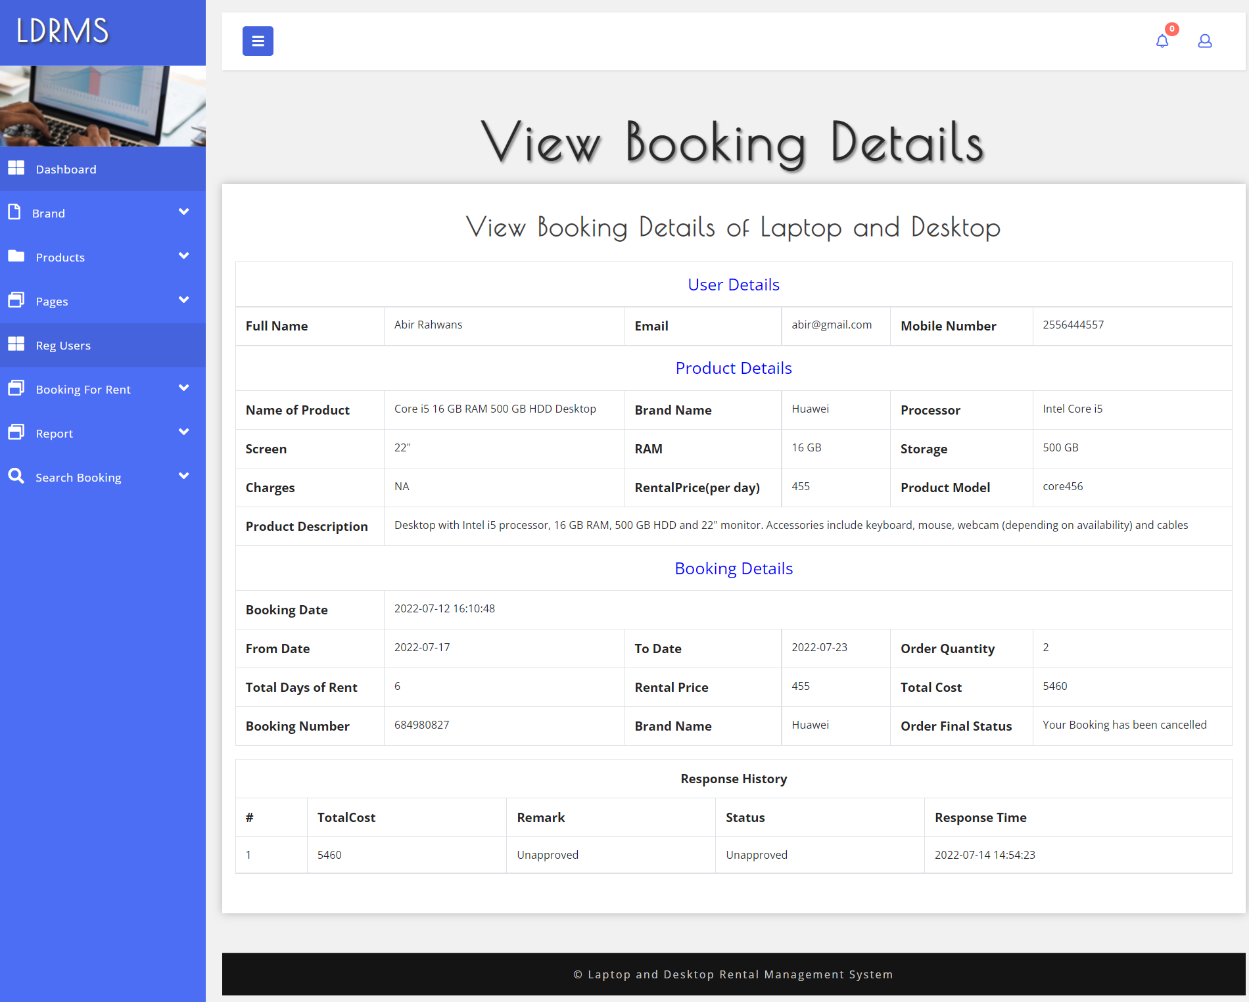

**B/w dates Reports**

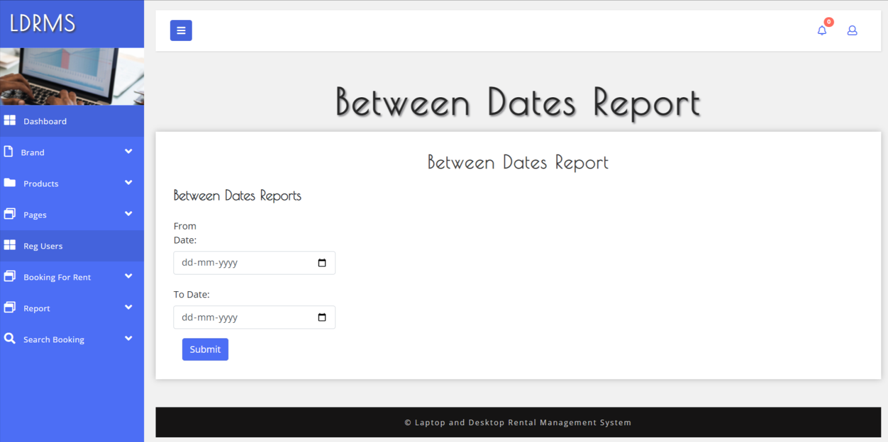

**View details of b/w dates reports**

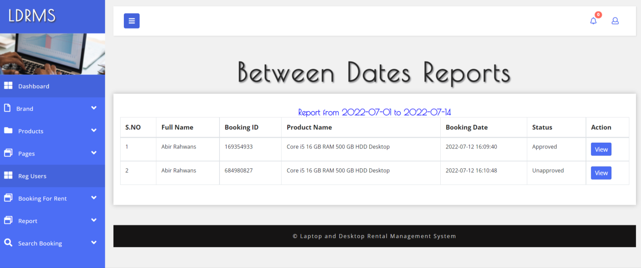

**Count Report**

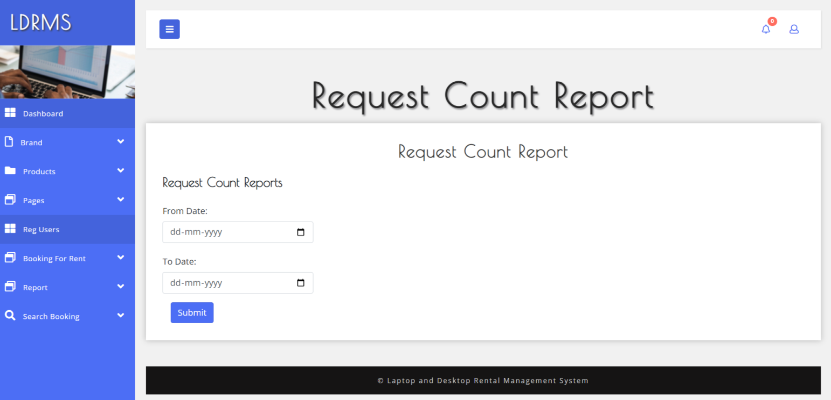

**View total counts of booking**

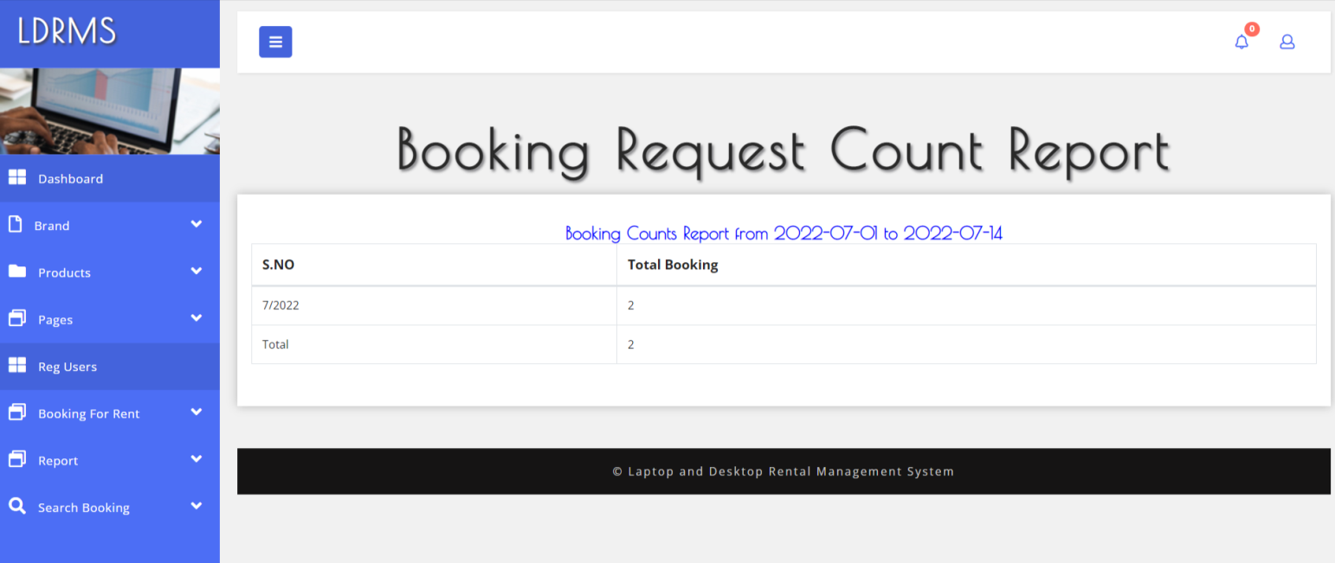

**Sales Reports**

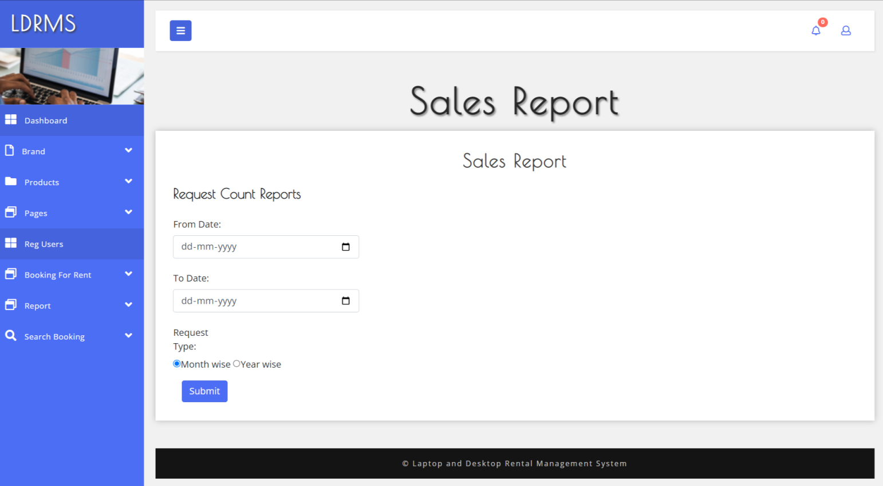

**View Sales Reports**

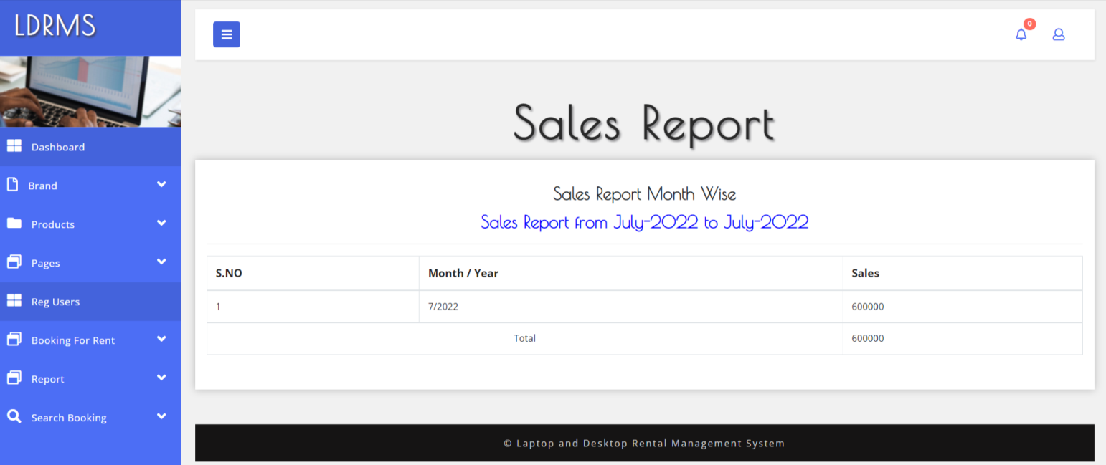

**Search Booking**

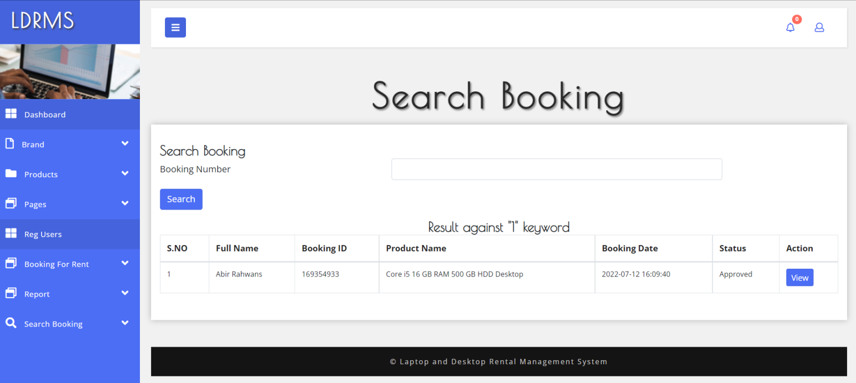

**Forgot Password**

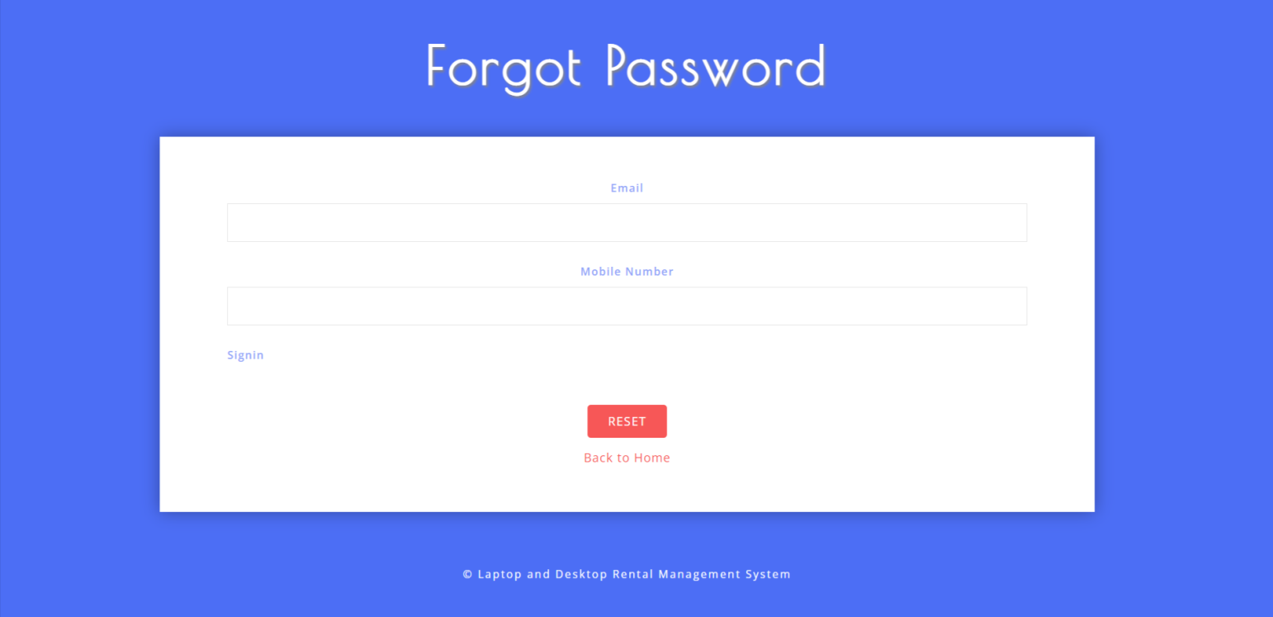

**Recover Password**

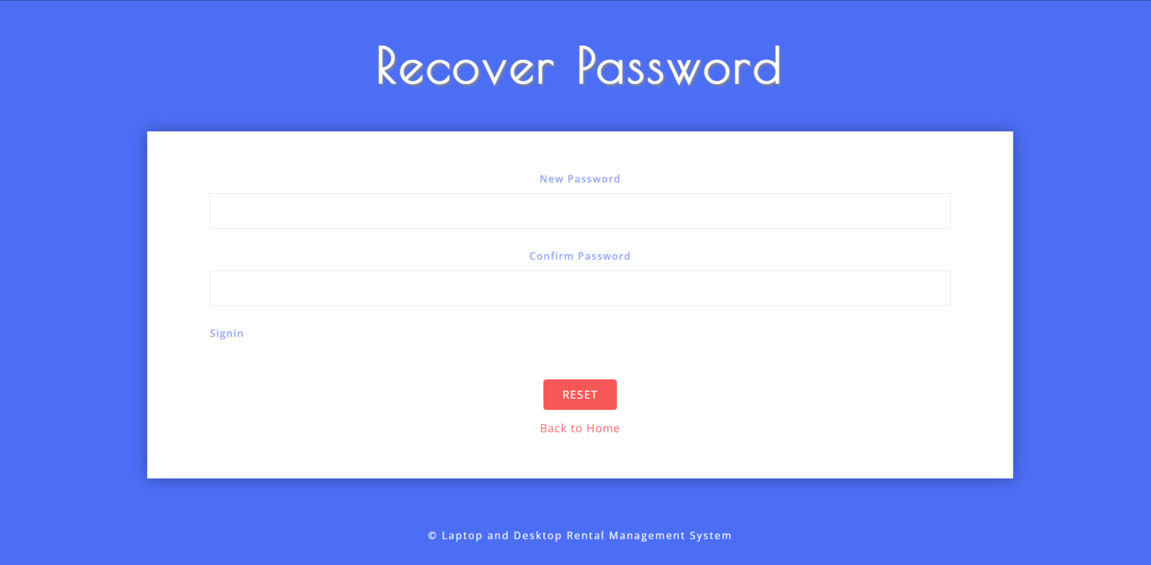

**4.2 Limitations**

### 1. **Scalability Issues**

* **Database Limitations**: MySQL can handle a significant amount of data, but performance may degrade with very large datasets or high user concurrency without proper indexing and optimization.
* **Server Resources**: Depending on the hosting plan, resource limitations (CPU, RAM) may affect the system's ability to handle high traffic.

### 2. **Performance Constraints**

* **Response Time**: As the number of simultaneous users increases, the response time may become slower if the application and database queries are not optimized.
* **Load Handling**: Without a proper caching mechanism (like Redis or Memcached), the system may struggle during peak usage times.

### 3. **Security Vulnerabilities**

* **SQL Injection Risks**: If not properly handled, user inputs can lead to SQL injection attacks. It’s crucial to use prepared statements to mitigate this risk.
* **Data Breaches**: Sensitive user data must be secured to prevent unauthorized access, which requires rigorous security practices.

### 4. **User Interface Limitations**

* **Responsiveness**: If not designed properly, the interface may not be fully responsive, leading to poor usability on mobile devices.
* **User Experience**: Limited design resources can result in a less intuitive interface, which may affect user satisfaction and engagement.

### 5. **Dependency on Internet Connectivity**

* **Online Availability**: Users need a stable internet connection to access the system, which may limit use in areas with poor connectivity.
* **Offline Functionality**: The system may not support offline operations, limiting flexibility for users in certain situations.

### 6. **Maintenance and Updates**

* **Ongoing Maintenance**: Regular updates are required to fix bugs, patch security vulnerabilities, and improve functionalities. This may require continuous developer support.
* **Technical Debt**: As features are added over time, the codebase may become complex, leading to maintenance challenges.

### 7. **Integration Limitations**

* **Third-Party Services**: Integrating with external payment gateways, CRM systems, or other tools can be complex and may lead to compatibility issues.
* **Limited APIs**: If the system relies on third-party services that lack robust APIs, it may restrict functionality.

### 8. **Legal and Compliance Challenges**

* **Data Protection Compliance**: Ensuring compliance with data protection regulations (e.g., GDPR) can be complex and requires ongoing attention to how user data is managed and stored.
* **Rental Agreements**: Legal enforceability of rental agreements generated by the system may need to be validated in different jurisdictions.

4.3) FUTURE Enhancement

### 1. **Mobile Application Development**

* **Native or Hybrid Apps**: Develop a mobile application to provide users with a seamless experience on smartphones and tablets.
* **Push Notifications**: Implement push notifications for reminders about rental returns, promotions, and new device availability.

### 2. **Advanced Reporting and Analytics**

* **Data Visualization**: Integrate tools for visualizing data trends and performance metrics through dashboards.
* **Predictive Analytics**: Use data analysis to forecast demand and optimize inventory management based on historical rental patterns.

### 3. **Enhanced User Experience**

* **Improved UI/UX Design**: Continuously update the user interface for better navigation and usability.
* **Personalization**: Offer personalized recommendations based on user preferences and rental history.

### 4. **Integration with Other Systems**

* **CRM Integration**: Connect the rental system with a Customer Relationship Management system to streamline customer interactions and support.
* **Payment Gateway Options**: Expand payment options by integrating multiple payment gateways for user convenience.

### 5. **Automation and AI Features**

* **Chatbots for Support**: Implement AI-powered chatbots for customer service, providing immediate assistance for common queries.
* **Automated Maintenance Alerts**: Use automated systems to notify staff of upcoming maintenance needs based on usage patterns.

### 6. **Multi-Language and Localization Support**

* **Language Options**: Add support for multiple languages to cater to a broader audience.
* **Localized Pricing**: Implement pricing models based on geographic location or user preferences.

### 7. **Enhanced Security Features**

* **Two-Factor Authentication (2FA)**: Add an extra layer of security for user accounts.
* **Data Encryption**: Ensure all sensitive data, including payment information, is encrypted both in transit and at rest.

### 8. **Sustainability Features**

* **Eco-Friendly Options**: Introduce features that highlight energy-efficient devices or promote recycling and proper disposal of old equipment.
* **Carbon Footprint Tracking**: Provide users with insights into the environmental impact of their rentals.

### 9. **Flexible Rental Options**

* **Subscription Models**: Offer subscription-based rental plans for users who need long-term access to devices.
* **Add-On Services**: Allow users to rent additional accessories (like chargers, bags) along with devices.

### 10. **Customer Feedback and Improvement Mechanisms**

* **Feedback System**: Implement a feature for collecting user feedback on devices and services to continuously improve offerings.
* **Review and Rating System**: Allow users to rate devices and share their experiences, enhancing community trust.

**Bibliography**

For PHP

<https://www.w3schools.com/php/default.asp>

<https://www.sitepoint.com/php/>

<https://www.php.net/>

For MySQL

<https://www.mysql.com/>

[http://www.mysqltutorial.org](http://www.mysqltutorial.org/)

For XAMPP

<https://www.apachefriends.org/download.html>